People Leaders

Approve Multiple Employee Timecards

You can approve multiple employee timecards at once at the end of the pay period for payroll processing by accessing the **Main Menu**.

**Navigation: UKG Navigation Bar**

1. In the **Navigation Bar**, select the **Main Menu**.

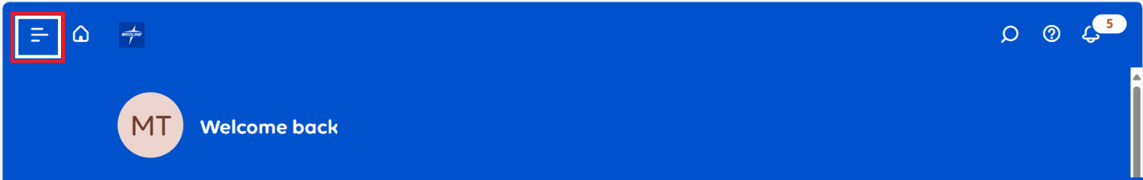

1. Select the **Time** dropdown and then select **Employee Timecards**.

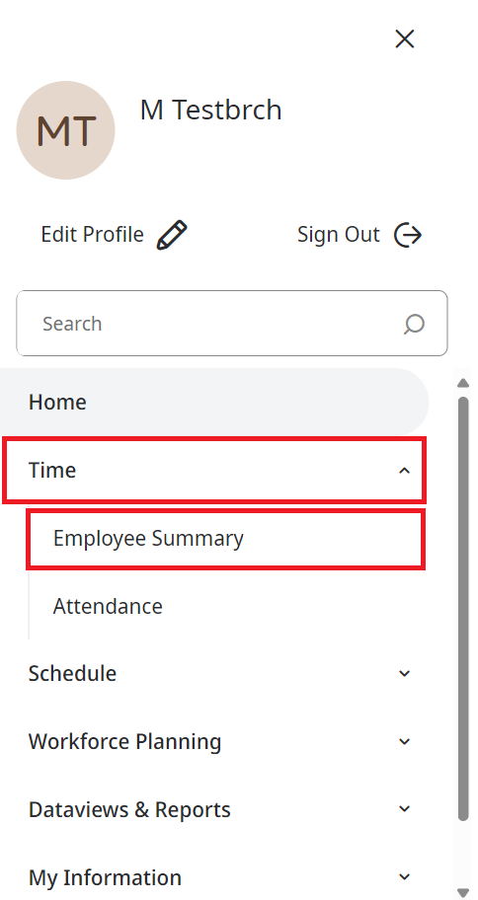

1. In the **Employee Dataview**, ensure the correct **Pay Period** is selected.

Review the timecards and resolve any missed punch and unexcused absence exceptions.

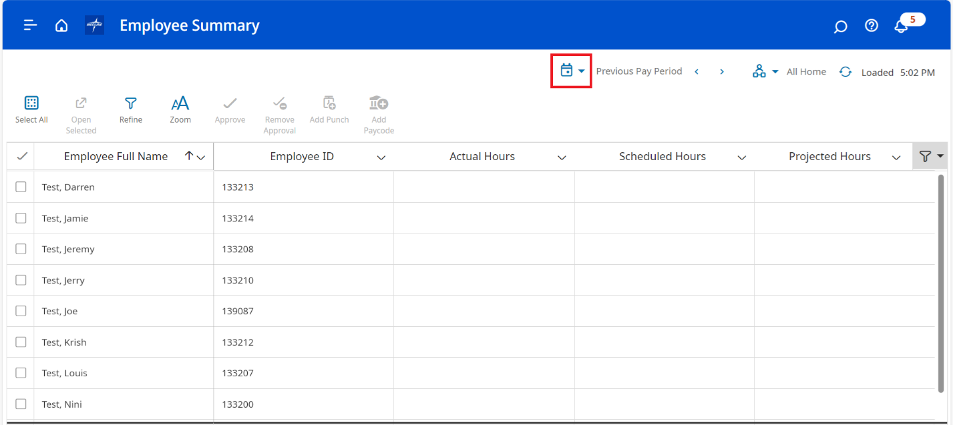

1. Select the check box next to each employee you want to approve. To select all the employees, click **Select All**.

1. Select **Approve**.

1. In the **Approve Timecard** dialog box, select **Yes** to confirm.