


People Leaders

Mark a Timecard Exception as Reviewed
You can mark an exception within an employee’s timecard as reviewed to signify you have reviewed the exception and are taking no further action. The Manage Timecards tile on the UKG Home Page indicates timecards that need to be reviewed.

NOTE: Marking as “Reviewed” does not impact attendance.

Navigation: UKG Home Page
- In the Manage Timecards tile, select Current Pay Period. Next to Need Review, select the View Need Review in Timecards arrow.
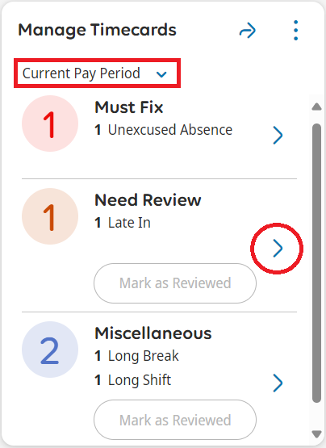
- Right-click on the exception indicator on the timecard to access the Punch Actions menu.
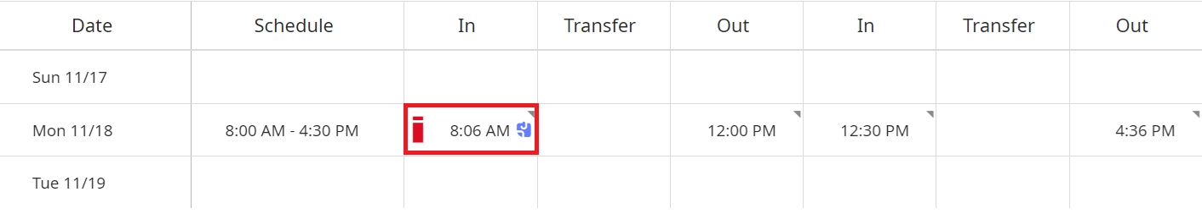

- Review the Punch Actions and select Mark as Reviewed.
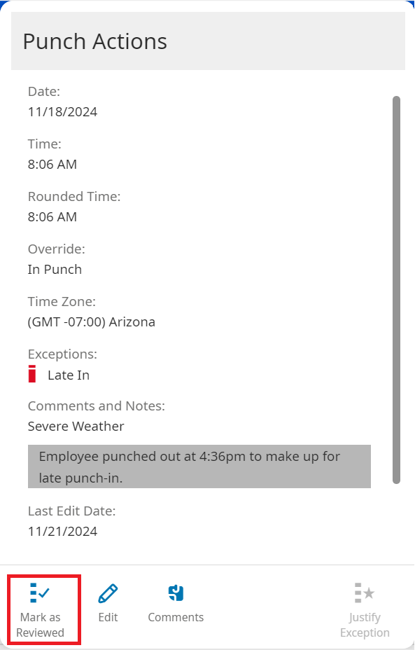
- Click Save.
