


People Leaders

Respond to Open Shift Requests
You can approve or refuse an employee’s request for an open shift by accessing the Control Center on the UKG Navigation Bar.

Navigation: UKG Navigation Bar
- In the Navigation Bar, select the Control Center.
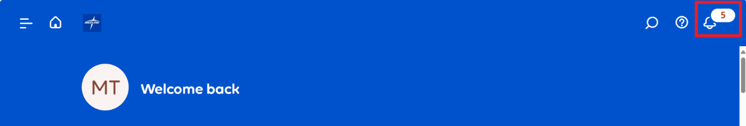
- In the Control Center, select the employee’s Open Shift Request Time to open it.
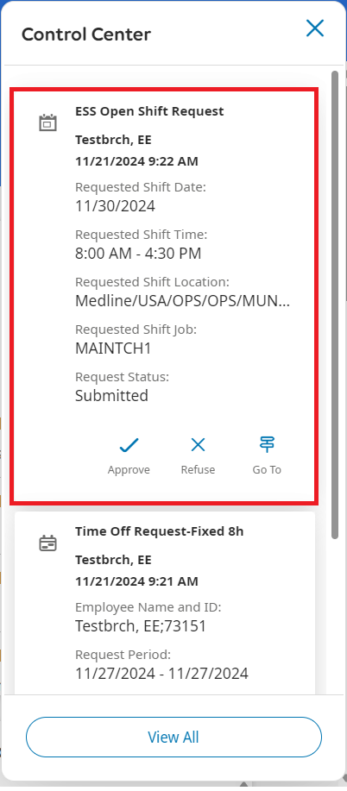
- Check the box to select the Open Shift Request and review the details.
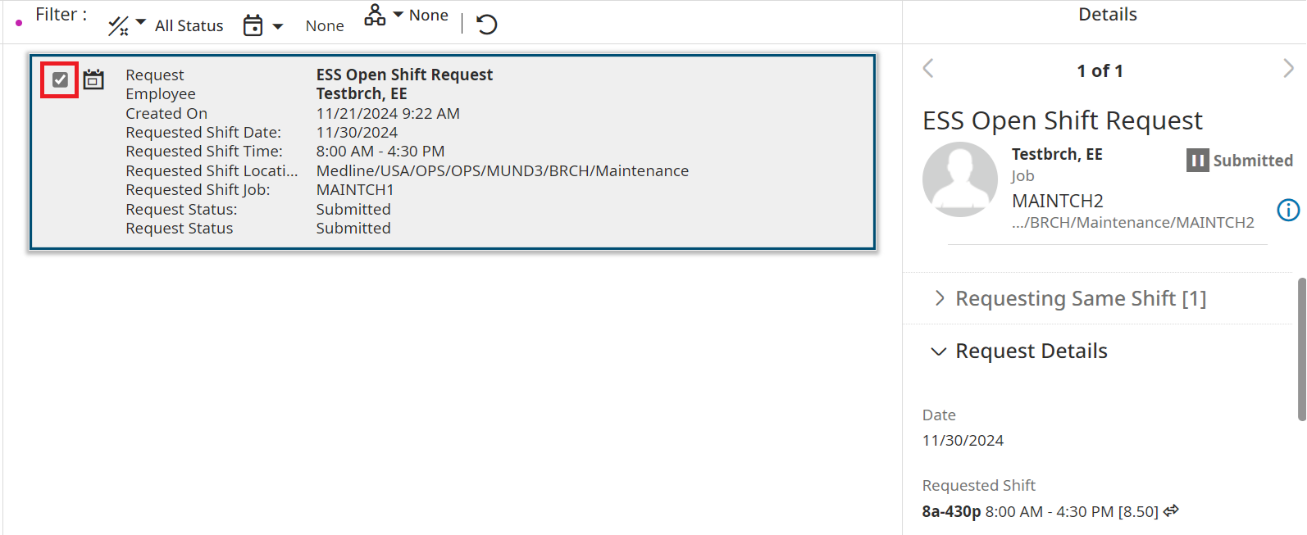
- Select Approve to confirm the request. Or Refuse to reject it. Optionally, add a comment or note.
