People Leaders

Access Employee Timecards

You can review the overall status of your employees’ timecards. You can select one of more employee timecards and apply the same action to selected employees.

**Navigation: UKG Home Page**

1. Select the **Main Menu** from the **UKG Home Page**.

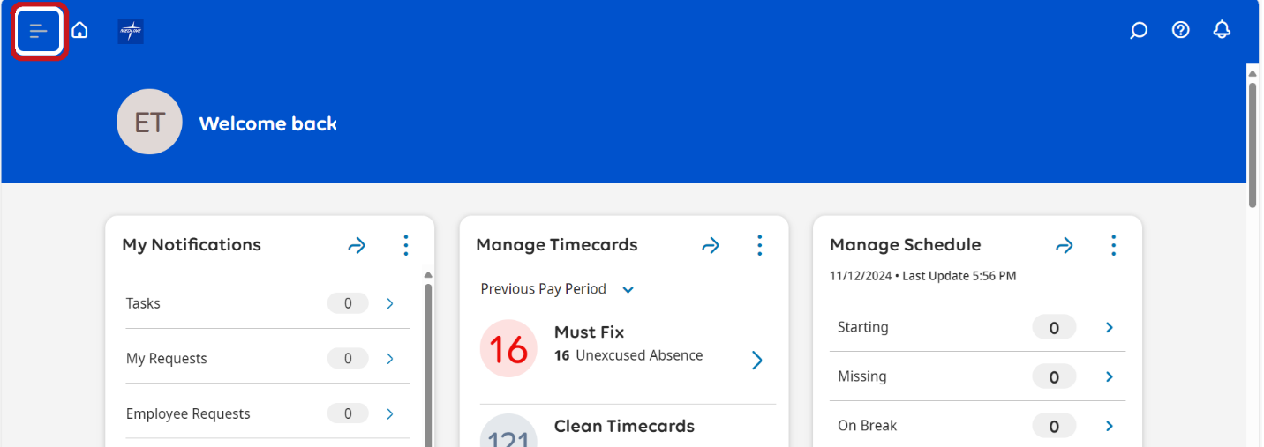

1. Select **Time > Employee Summary**. You will be directed to the **Employee Summary** dataview.

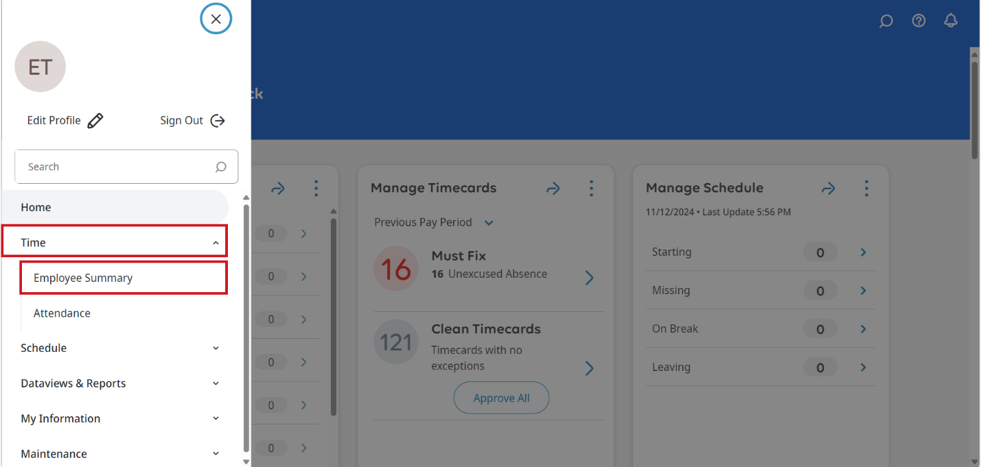

1. In the **Employee Summary**, select the box next to the employee you want to review. You can select one or more employees or use **Select All** to select all employees.

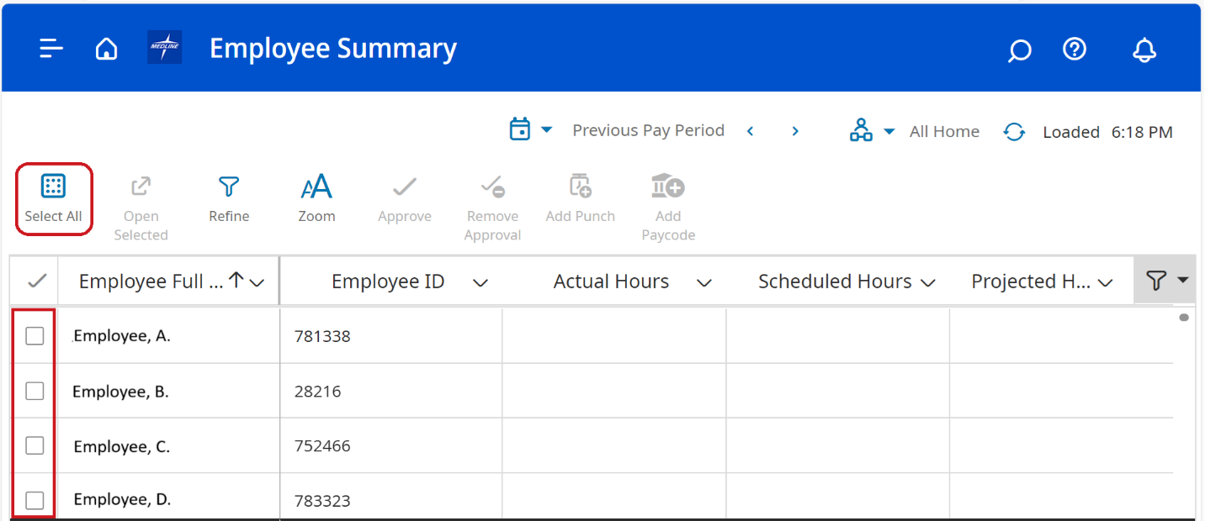

1. Select **Open Selected**, which will open the first employee timecard.

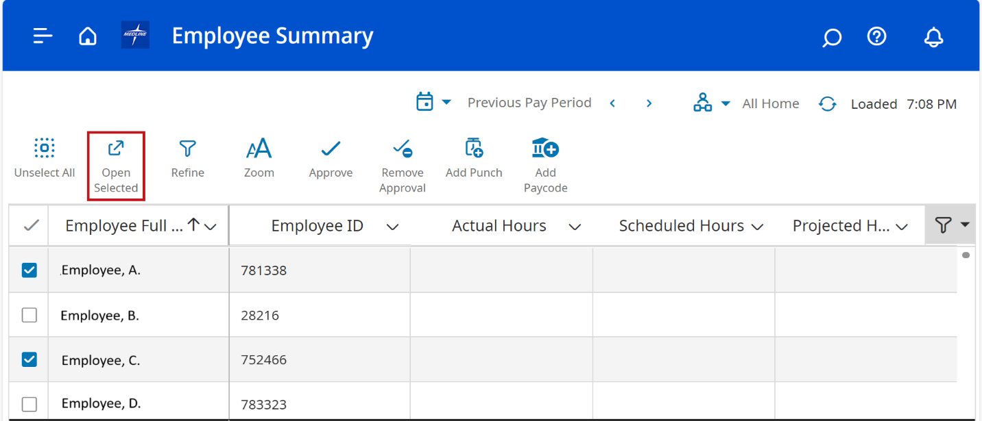

1. Select the **Calendar** dropdown for the timeframe you want to review.

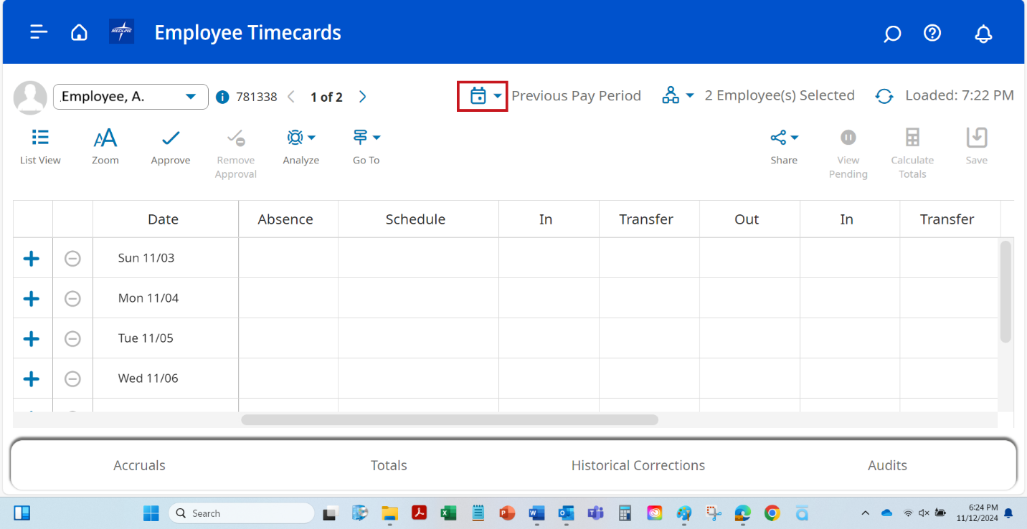

1. Click on the arrow to view the next employee timecard you selected to review.

