


Employees

View Attendance Points Accumulated
You can view your attendance point balances and individual attendance events using the Attendance Point Balance by Employee Name tile on the UKG Home Page.

Navigation: UKG Home Page
- On the Attendance Point Balance by Employee Name tile, which displays a summary of your attendance points. Select the arrow for a detailed view of your point balances and individual attendance events.
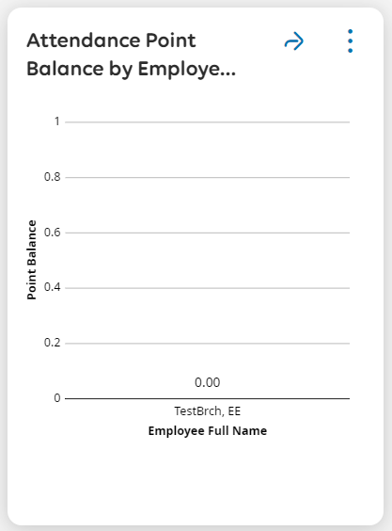
- Select the Calendar dropdown or Date Range arrows to view specific timeframes.
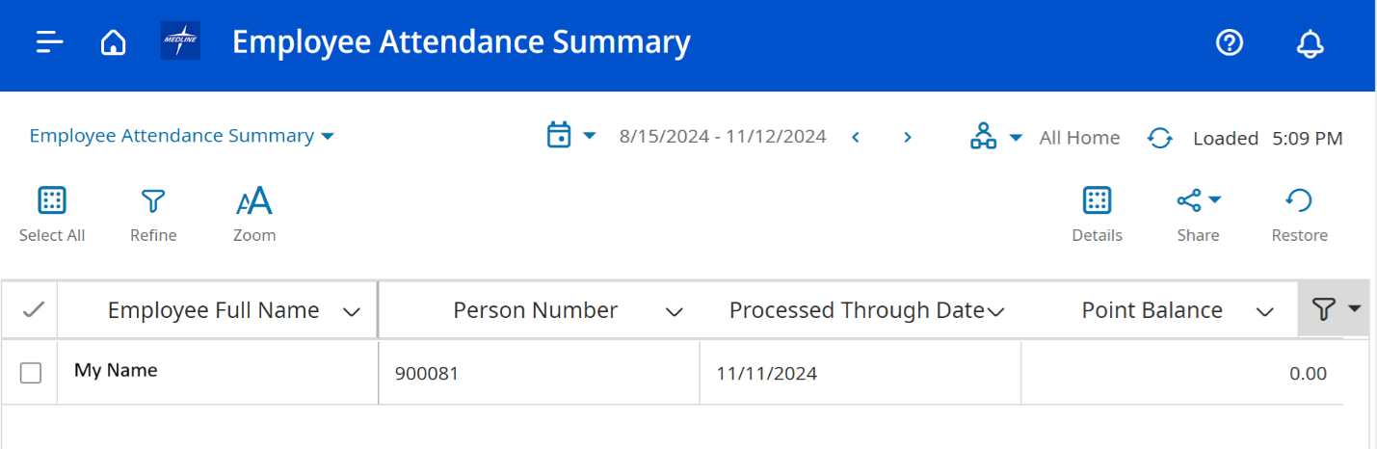

NOTE: The Employee Attendance Summary only displays when points were received and not when/if points fall off.

