


Employees

Respond to a Shift Swap Request
You can respond to a shift swap request from another employee by accessing the Control Center.

Navigation: UKG Home Page
- On the navigation bar, click the Notifications icon to open the Control Center panel.
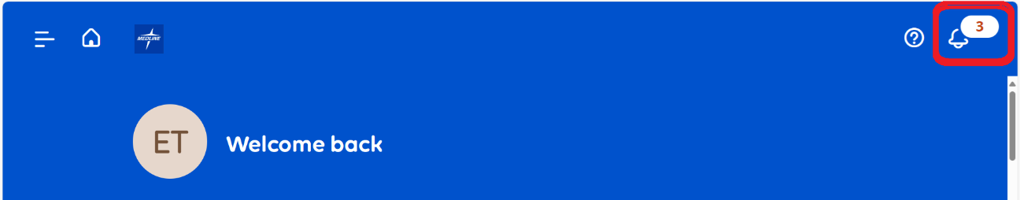
- In the Control Center panel, review the details of the Offered Shift and My Shift.
Do one of the following:
Click Accept to accept the offered shift.
Click Reject to reject the shift.
