Employees

Request to Swap Shifts

You can request to swap a scheduled shift with a shift that is scheduled for another employee by accessing the **My Schedule** tile on the **UKG Home Page**.

**Navigation: UKG Home Page**

1. In the **My Schedule** tile, select the **View My Schedule** arrow.

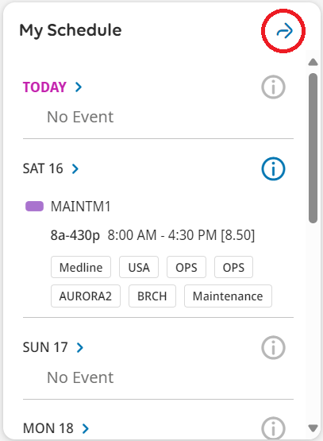

1. Click **Request**, then click **Swap shifts** to access the **Request Shift Swap** panel.

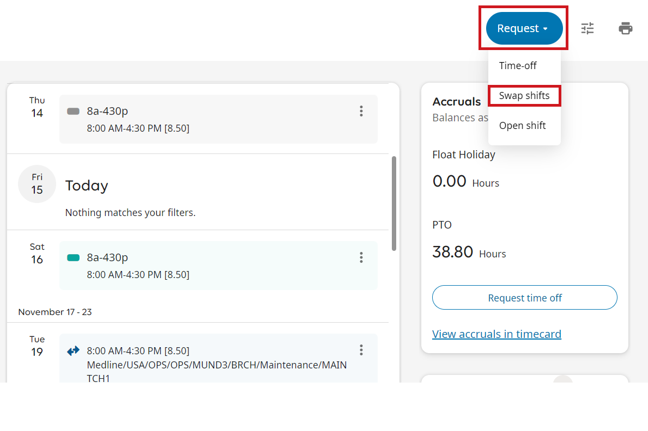

1. In the **Request Shift Swap** panel, scroll to the shift you want to swap and select it.

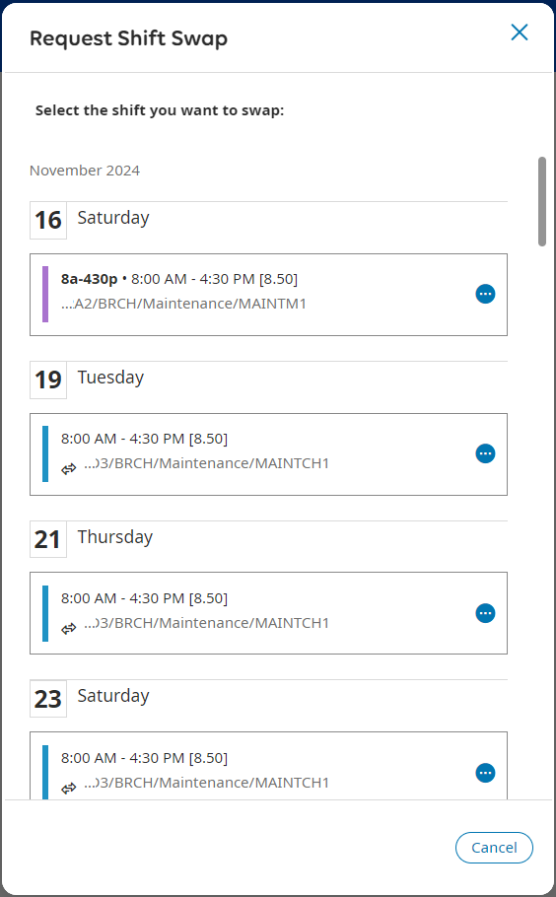

1. Under **Available Shifts**, select the shift and colleague you want to swap your shift with. You can also use the Search field to search for a specific employee by name or refine your search.

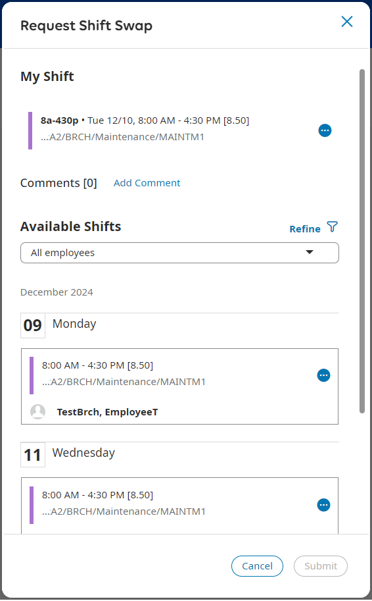

1. The **Request Shift Swap** panel refreshes to show a summary of the shift you offered to swap and the colleague's shift you want to swap with. Click **Submit**.

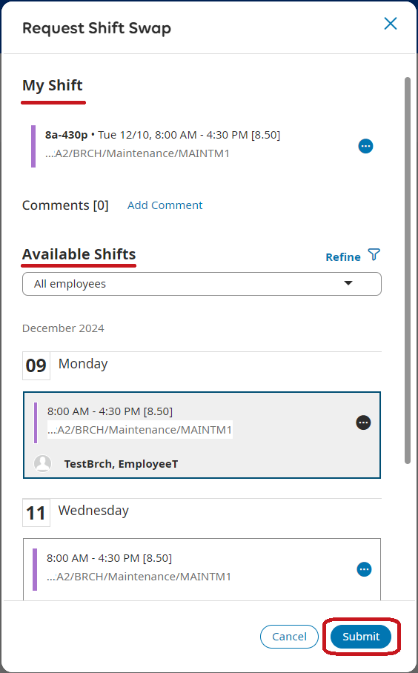

1. Click **OK** to submit the request or **Cancel Request** to cancel the request. By clicking OK this request will be sent to colleague for approval/denial.

