


Employees

Request Open Shifts
You can review and request available open shifts when the request period is open by accessing the
My Schedule tile.

Navigation: UKG Home Page
- In the My Schedule tile, select the View My Schedule arrow.
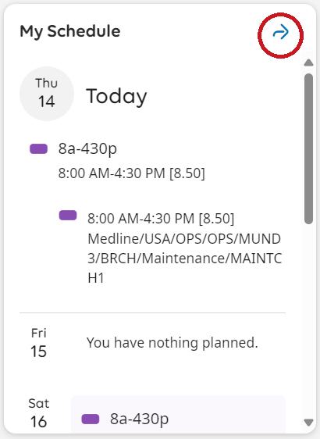
- Click Request, then click Open shift to access the Request Open Shift panel.
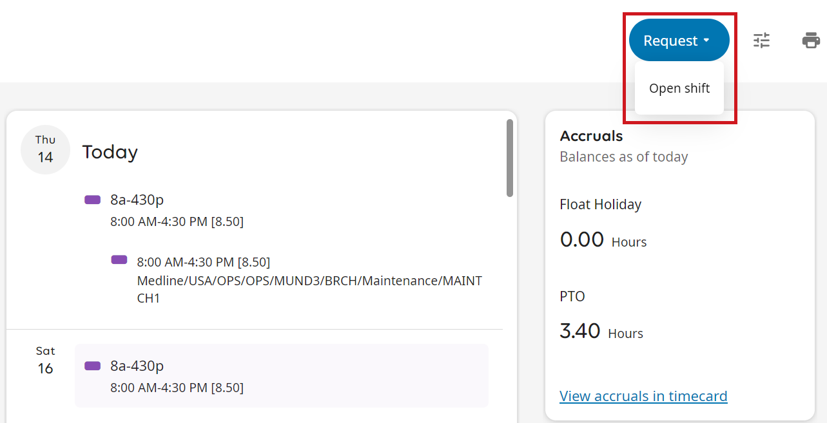
- In the Request Open Shift panel, scroll to your desired open shift and select it. You can select only one open shift at a time. To return to the previous screen without making a selection, click Cancel.

Click Submit to request the selected shift. To view details, click on the View Details icon and
click Ok when done.
