


Employees

View My Accruals
You can view your hourly balances for multiple accruals for any day using two options from your UKG Home Page: directly on the My Accruals tile or from the My Timecard tile.

Navigation: UKG Home Page
Option 1 - On the My Accruals tile, click on the Balance as of Today dropdown arrow to select a past or future date. Use the left and right arrows to move to the different accrual codes to view your balances.
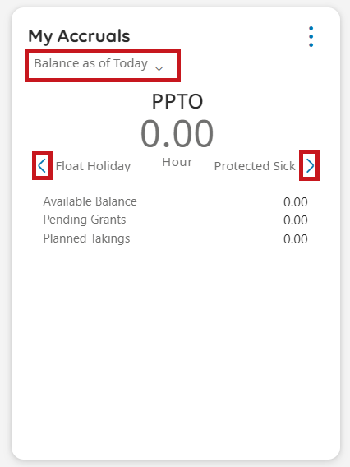
Option 2 - On the My Timecard tile, select the Open My Timecard arrow.
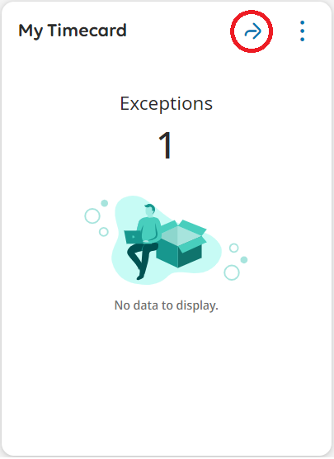
Select the Accruals tab at the bottom of My Timecard to view your balances.
