


Employees

Correct a Missed Punch Using Attestation
You can correct a missed punch using the attestation feature. The My Timecard tile indicates a missed punch or exception in your timecard.

Navigation: UKG Home Page
- In the My Timecard tile, select the Open My Timecard arrow.
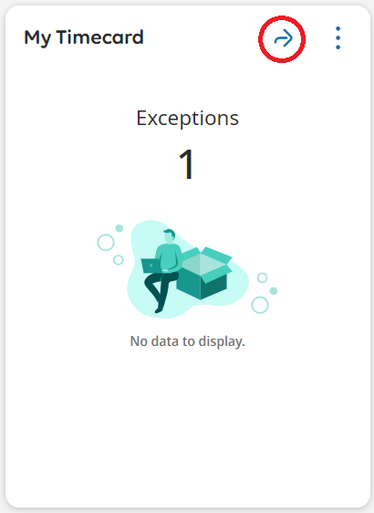
- Locate the missed-out punch and right-click in that field. Click in the red box and update the time.
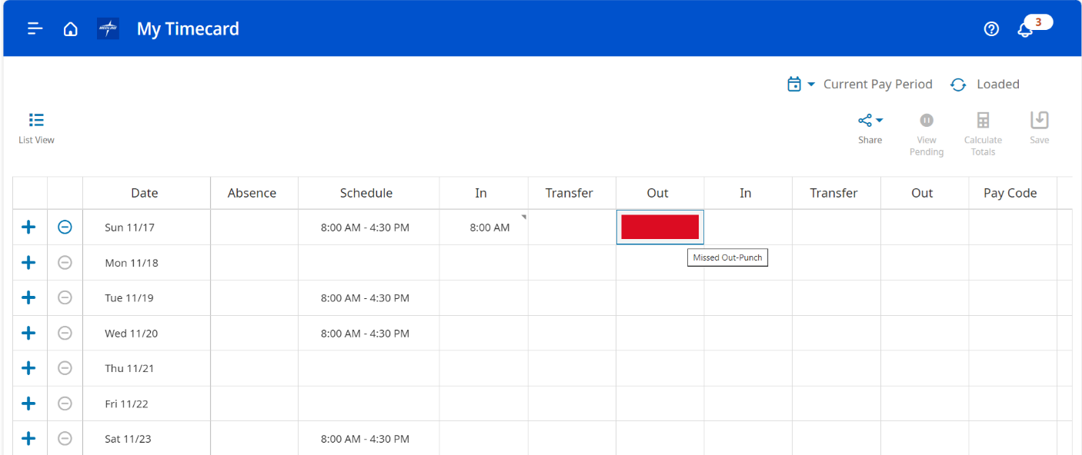

- Click Save.
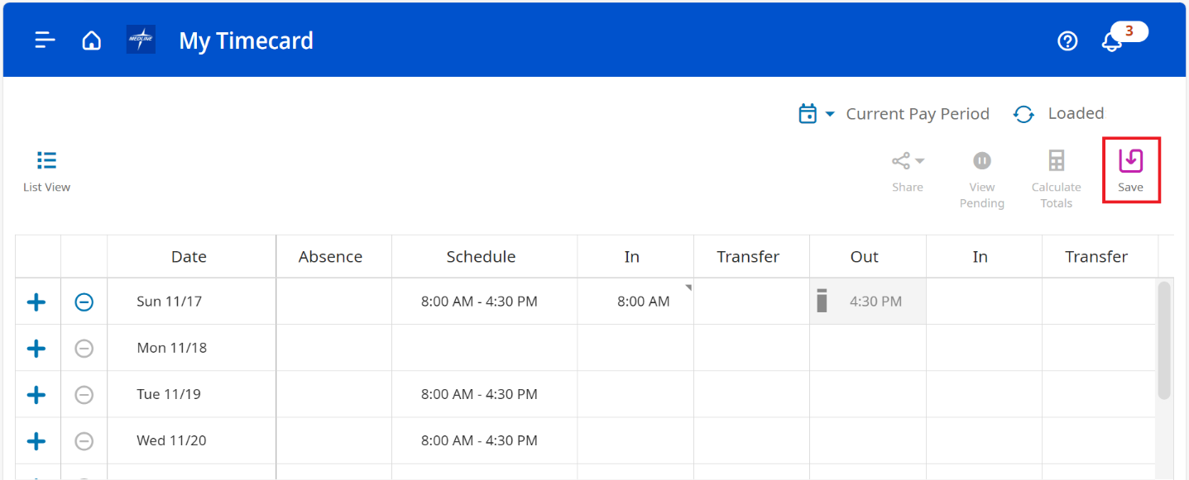
- Your change has been submitted but will not display until approved. Click View Pending from the action bar to view your pending change.
