**Workday Mobile App**

Employees

For employees looking to use the Workday Mobile Application, this document will guide you through the following tasks and processes:

**Workday Mobile App Set-Up and Logging In**

How to login to Workday Mobile App.

**Workday Mobile App Navigation**

How to find and use the following features on the Mobile App: Homepage, Applications, My Tasks, the Find function.

**Accessing your Personal Information**

How to view and edit personal information such as Job, Compensation, Pay, Contacts, Personal Data, Performance and Career information.

**Viewing your Org Chart**

How to access a hierarchical overview of your organization, including your peer colleagues and supervising Manager.

**Differences Between Desktop View and Mobile App**

Learn about a couple of key differences between Workday’s Desktop View and the Mobile App.

Workday Mobile App Set-Up and Logging in

1. To get started, download the Workday application from the **Google Play Store** or **Apple App Store.**
2. When you open the app, click **Log In**. You will be prompted to **Enter or Scan your Organization ID**. Your organization ID is **medline**. Or you can scan your company QR code (shown below).



1. You can also access your **Organization ID** through the Workday website. Click the **Avatar** () icon in the top right-hand corner. Select **My Account**. Select **Organization ID** to see your organization’s QR code.

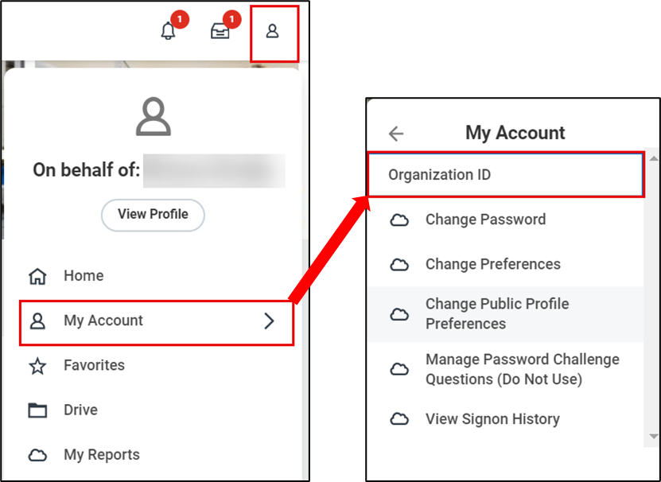

1. You will be prompted to sign in using your Medline single sign-on (SSO) credentials.

Workday Mobile App Navigation

Once you have signed on to the Workday app on your mobile device, you can access applications such as **Announcements**, **Org Chart**, **Personal Information**, **My** **Tasks** and more!

|  |  |
| --- | --- |
|  | Please note that not all Workday applications available on the desktop website will be available on the Mobile app. |

1. When you log on, you will see your Workday Homepage. Here you will see suggested apps.

1. To toggle between the **Homepage**, **Applications**, My **Tasks**, the **Find** function and your **Workday** **Profile** by clicking the icons at the bottom of your screen.

1. Click the **My** **Tasks** icon in the bottom of your screen. You will be directed to your **My Tasks** **Inbox** to view tasks requiring your approval or items to complete.

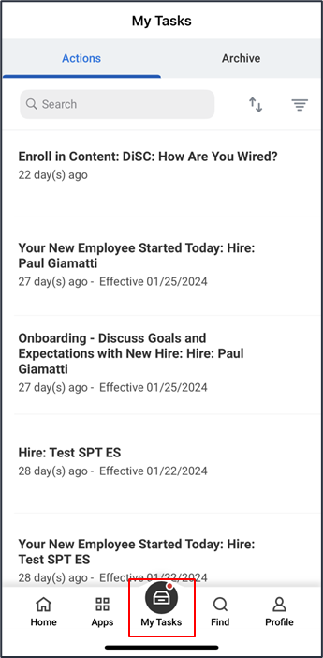

|  |  |
| --- | --- |
|  | Please note that Managers will receive inbox **Tasks** and **Notifications** via the Workday Mobile App for *all* business processes. However, some tasks may not be completed/approved using the mobile app. |

1. To access all other Workday applications, click the **Apps** icon in the bottom left-hand corner. Select which app you would like to use by clicking on it.

Accessing Personal Information

1. Access your **Workday** **Profile** by clicking on the **Profile** icon in bottom right-hand corner.

1. Once you are on your **Workday** **Profile**, scroll down to view information related to your **Job, Compensation, Pay, Contacts, Personal Data, Performance** and **Career**.

1. From your **Profile** page, click the **Edit** icon () next to your name.

1. Here you will see options to modify your **Personal Information** such as **Change My Legal Name**, **Change My Name Pronunciation**, **Change My Personal Information**, **Change My Photo** and **Change My Preferred Name**. Select an option to make changes.

1. To edit or add information, click on the **Edit** icon () next to the personal information listed. Please note any field with a red asterisk (*) is required to proceed.

1. Once you have completed all sections, click **Submit** to finalize or **Save for Later** to complete at a later time.

1. You will receive a message that your change has been submitted. Your changes may need to go through an approval process. Once your change has been approved, you will receive a notification.

Viewing your Org Chart

1. From your **Workday Profile**, you can access your **organization chart** by clicking on the **Team** button under your name.

1. Once selected, the **Org Chart** will show you a hierarchical overview, including your peer colleagues and supervising Manager.

1. To learn more about a colleague, simply select their name and you will be brought to their **Workday** **Profile**.

|  |  |
| --- | --- |
|  | Please note that when you navigate to a colleague’s **Workday Profile**, or when they navigate to yours, only limited information will be displayed. For example, although you can see your Compensation information in your own **Workday Profile**, you would not be able to see your colleague’s if you navigated to their **Workday Profile**. |

Differences Between Desktop View and Mobile App

There are some differences in how you view information and perform tasks between the Workday desktop application and the Workday mobile application. Luckily, these differences are minor, and Workday maintains much of the same look and feel between mobile and desktop versions.

**Here are a couple of key differences to note:**

1. In the desktop application you will click the Medline logo in the top left-hand corner to return to the Workday Homepage. Meanwhile in the mobile application, you will click on the **Home** icon that appears in the bottom left-hand corner to return to the Homepage.
2. In the desktop application, your tasks appear in your **My Tasks** I**nbox** in the top right corner. However, in the mobile application, your **Tasks** can be accessed from the bottom of the screen.
3. Finally, in the desktop application the **Search** function can be found at the top of the screen. In the mobile app, the search function is called **Find** and it can be found at the bottom of the screen.
4. To view all Apps in the mobile application, click on **View All** or click on the **Apps** icon at the bottom of the screen.