

Accessing Pay Information
Payroll, HR, Benefits, Finance

For members of Payroll, HR, Benefits, and Finance looking to familiarize themselves with common payroll processes, this document will guide you through the following tasks:
Managing Payment Elections
How to select preferred payment methods and update bank account information for payroll transactions.
Viewing Employee Payroll Results
How to view detailed information about your earnings, deductions, taxes and more.
Managing Tax Elections
How to update federal and state tax withholding information.
Viewing and Printing Payslips
How to access and download payslips for different pay periods.
Conducting Payroll Reporting
How to generate pre-built or custom reports to analyze payroll data.
General Ledger
How to view or edit account posting rule sets and account sets.

Managing Payment Elections
- To get started, click the Pay application from your Workday Homepage.

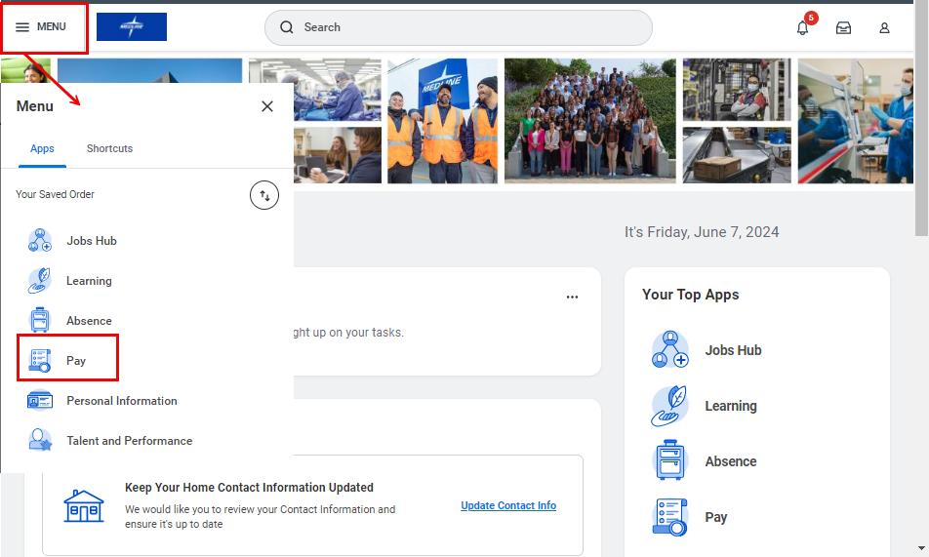

- Under the Elections menu, click Payment Elections.

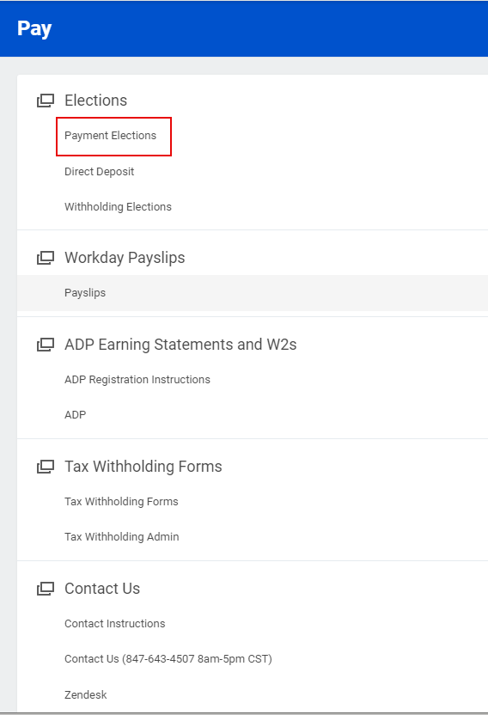

- Under Accounts, click Edit to update an existing payment election or Add to add an additional payment election.

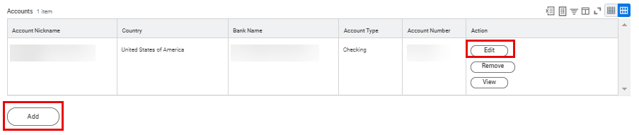

- Enter Account Information for your bank account, including Routing Transit Number, Account Number and Bank Name. Then, click OK.

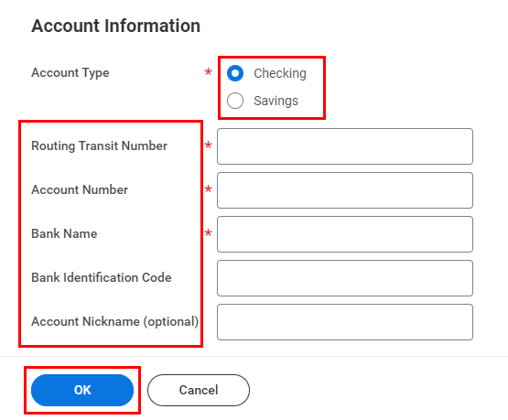

You can find this information on a blank check, as per the sample below.

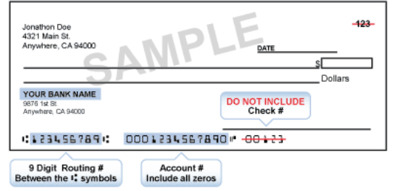

Please note that there is no pre-note. Check your information carefully to ensure accuracy.

- Next, scroll down to the Payment Elections table. Click Edit.
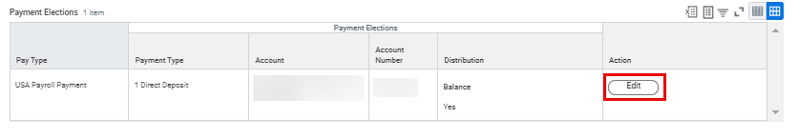

- Select your preferred Payment Type from the drop-down menu.

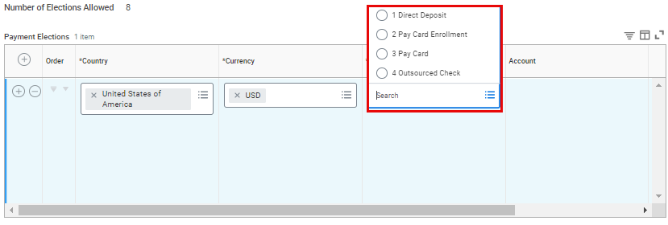
- If you would like to split payments between different accounts and only see one account listed, click on the Add icon () and select the account from the drop-down menu. Select United States of America in the Country column and the Currency will auto-fill to USD. Select your preferred Payment Type and select the account you would like to direct your payment to from the drop down menu. Then allocate payments as desired by Amount, Percent or Balance.

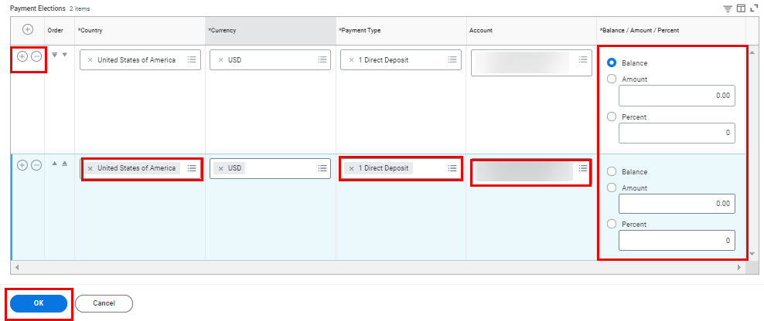

Please note that if you are splitting payments into multiple accounts, the last row (account) in the list must have the Balance selected, or the total percentage of all accounts must equal to 100.

- Once finished, click OK.



- A confirmation message will appear to notify you that your changes have been saved. You will also receive an automated email confirmation.



Viewing Employee Payroll Results
- First, navigate to your Profile. To do so, click the Profile icon from the top right-hand corner of your Workday Homepage, then select View Profile.

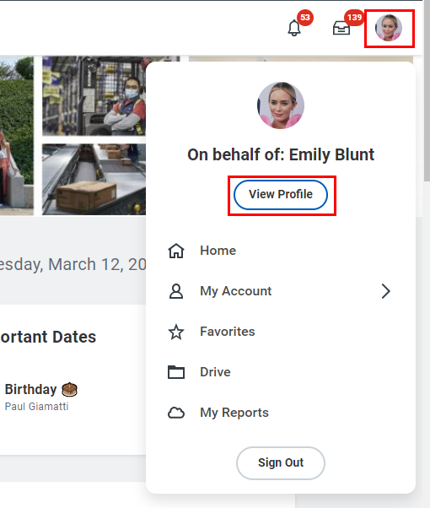

- On the left sidebar of the page, select Pay.

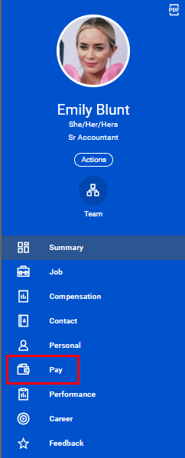

- You will be directed to your Payroll Results page, where you can view your Pay Calculation by Period.

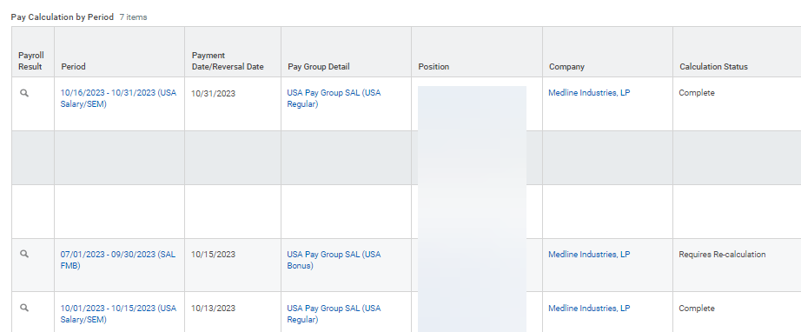

- To view more detailed information about a specific Payroll Result, click on the Magnifying Glass icon () next to it. This will provide you with additional details such as the calculation of Gross to Net Pay, Benefits, Taxes, and more.

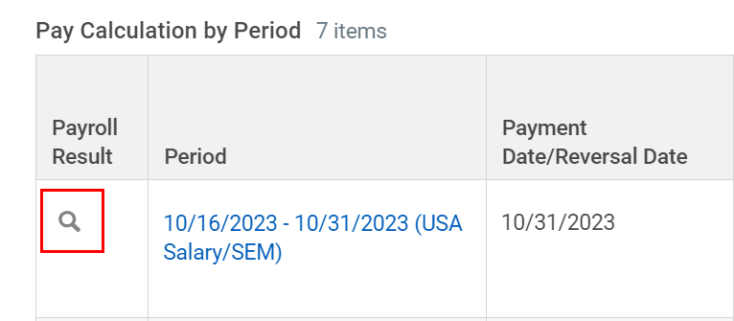

- Toggle between the tabs titled Additional Pay Components, Payroll Input, Pay Accumulations / Balances, Tax Elections, Payment, and Actuals for more information on this specific payroll result.

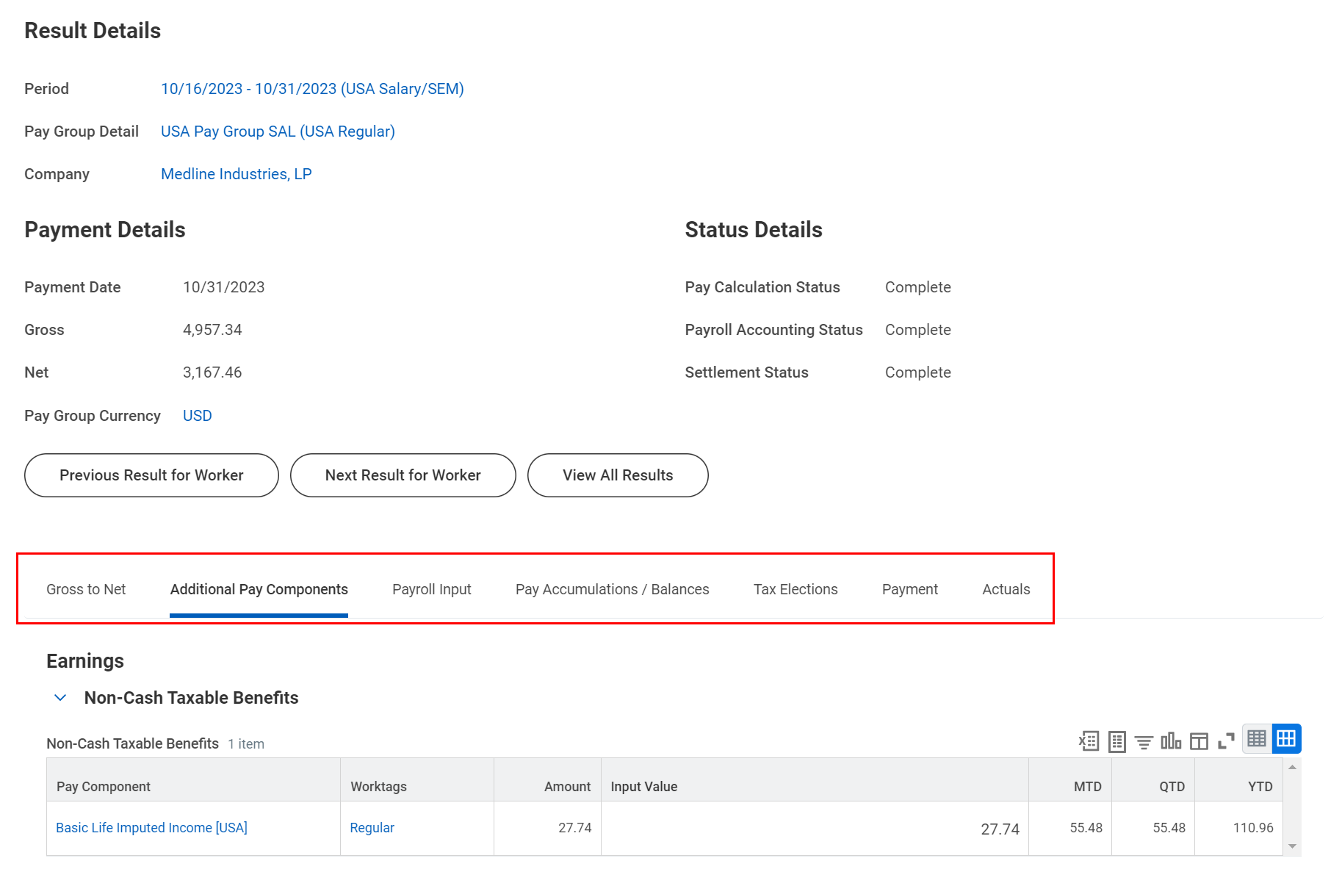

Managing Tax Elections
- To get started, click the Pay application from your Workday Homepage.

- Under the Tax Withholding Forms column, click Tax Withholding Forms.

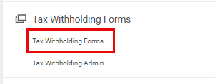

- You will then be redirected to the CIC Plus webpage, where you can proceed to update your tax withholding elections.

Viewing and Printing Payslips
- To get started, click the Pay application from your Workday Homepage.

- Under the Workday Payslips menu, click Payslips.

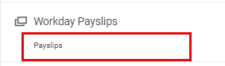

- The My Payslips page displays a summary of all your payslips to date. Next to each payslip record, you will see details about that particular payslip, such as the Payment Date, Gross Amount and Net Amount. You can also View or Print each payslip from here. Select View to be taken to the Payslip details.
Please note that payslips will not be available in Workday until the first payrolls are processed once Workday goes live.

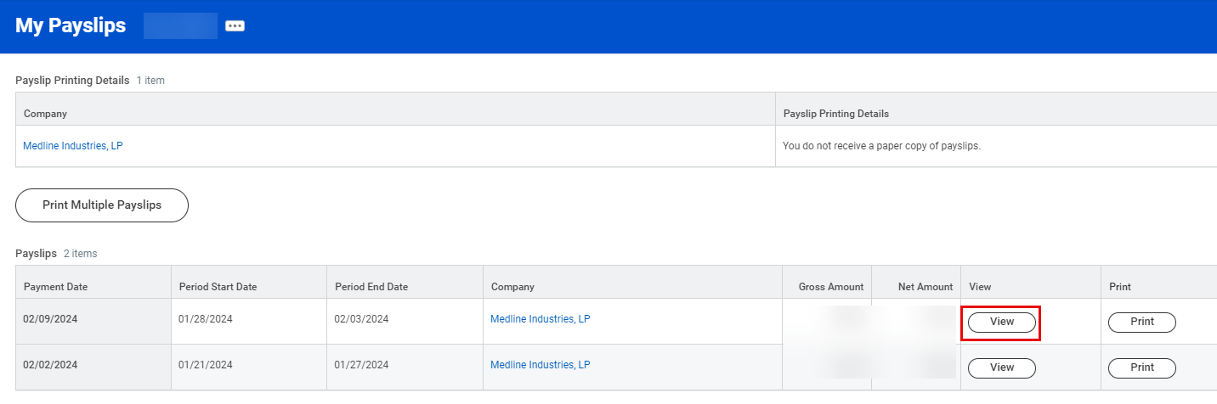

- Click View to see a detailed view of the selected payslip, including Current and YTD Totals, Earnings, Tax Information and more. You can export any of this information to Excel by clicking the Export to Excel () icon, and you can expand the view for easier reading by clicking the Expand () icon. From the top of the Payslip page, you can access:
- Previous Payslip – View your payslip for the previous pay period
- Return to My Payslips – Return to the previous page to see an overview of all your payslips
- Print Payslip Image – Print a copy of this payslip
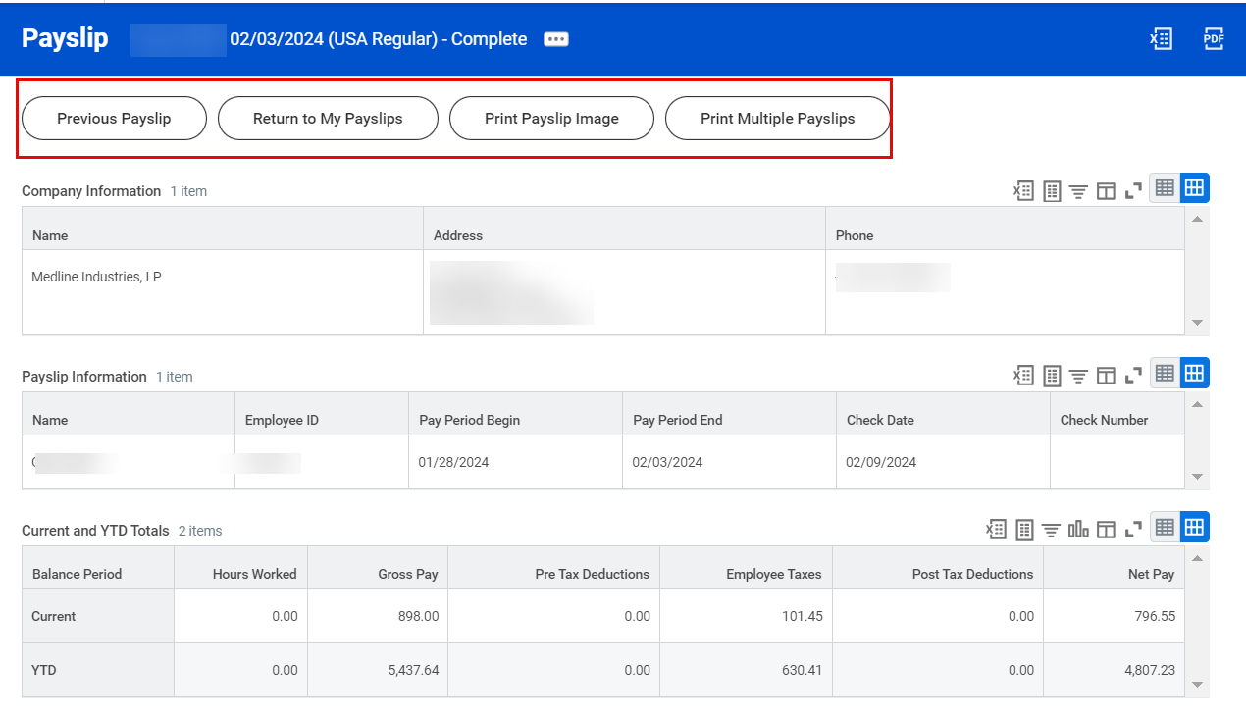
- Print Multiple Payslips – Print copies of multiple payslips all at once for your convenience

- There are multiple ways to print a payslip(s). From the My Payslips page, select Print to print a copy of an individual payslip, or Print Multiple Payslips to print multiple payslips at once. You can also complete this action from the Payslip details page (pictured above).
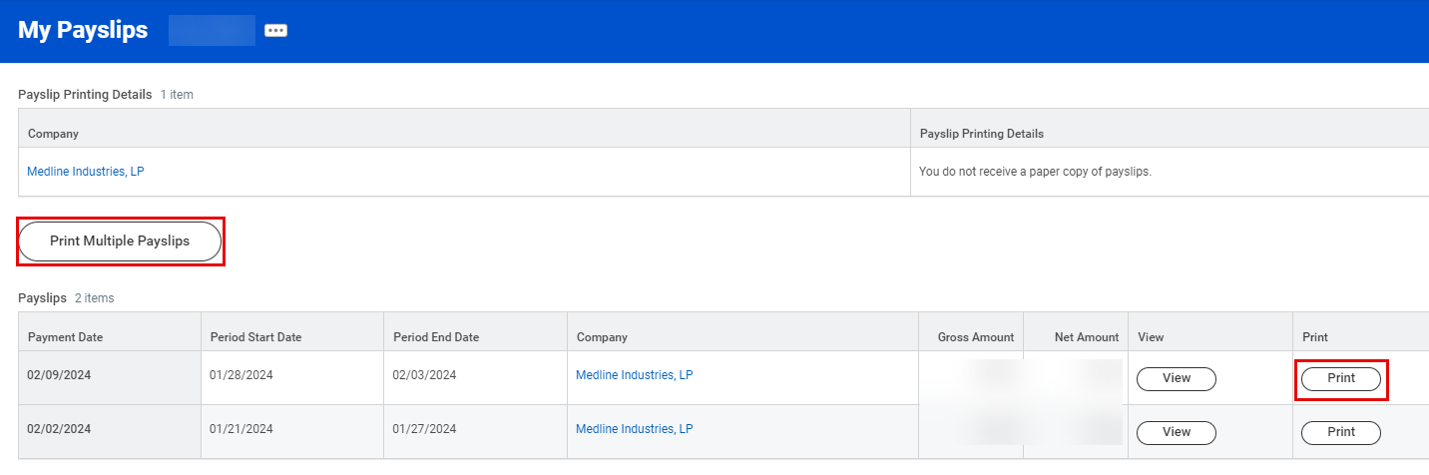

- If you select Print Multiple Payslips, you will be asked to input the following information. Then, click OK.
- Payment From Date and Payment To Date: Aggregate all payslips within the selected payment period.
- Exclude Net Zero Payslips: Exclude any payslips with net zero earnings from your search.
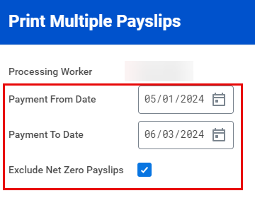

- On the next page, review all the payslips within the given Payment Date Range. Select the checkboxes in the table for the payslips you wish to print within the Payment Date Range, or select the top checkbox in the top row of the table to print them all. Then, click OK.
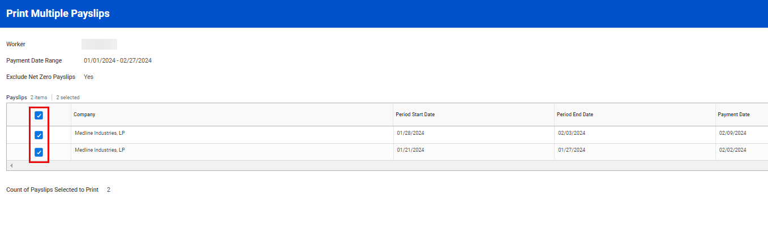

- Your payslip documentation will pop up automatically or a dialogue box notifying you that Workday is processing your request will appear. You can request that Workday notify you once the image is ready by clicking on Notify Me Later.
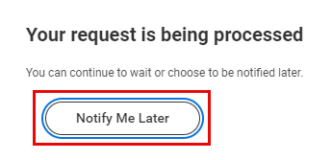

- If you have chosen the Notify Me Later option, Workday will send you a notification when your payslips are available for printing. You can access your notifications by clicking on the Bell icon () at the top right corner of the page. Once in your Notifications page, click on the Document Available item in the left pane. Following this, click the PDF beside Details on the right-hand side of the screen to open the payslip image.
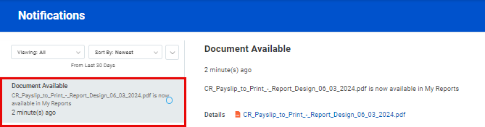

Please note that you can only view your current payslip two days before the actual payment date.

Conducting Payroll Reporting
- In the Workday Search Bar, type “Workday Standard Reports”, then select the corresponding Report.

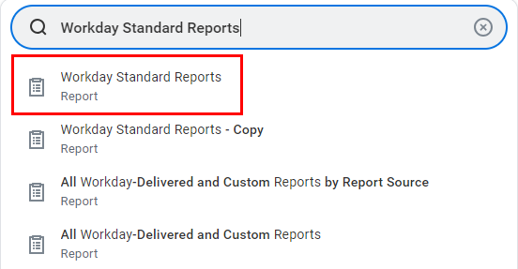

- In the Report Categories drop-down menu, you will want to select Payroll Processing/Results and Worker Data to report on payroll. You can either scroll through the list or type in a few characters to narrow down your search to find these categories. Then, click OK.

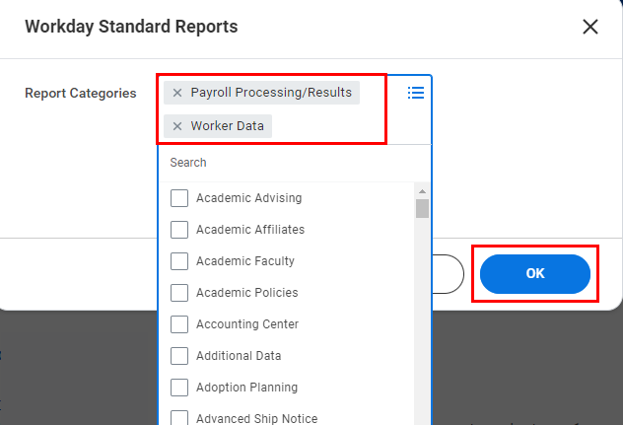
- From here, we recommend that you export the data to Excel using the Export to Excel () icon to filter and sort through the large amount of data.

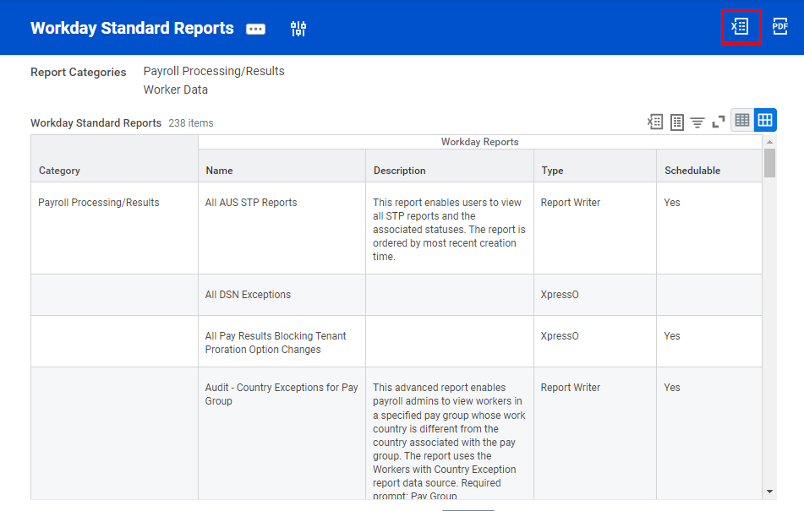

Please note that the exported data will include reports from all countries. To ensure that you only include reports relevant to the country you are reporting on, make sure to filter the Name column, where you may find “UK” “CAN” in the title.

General Ledger
- In the Workday Search Bar, type “View Account Posting Rule Set,” then select the appropriate report.

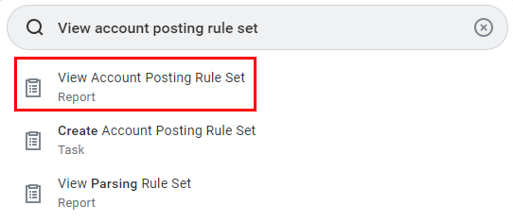

- From the Account Posting Rule Set drop-down menu, select All, then Medline Posting Rule Set. Click OK to proceed.

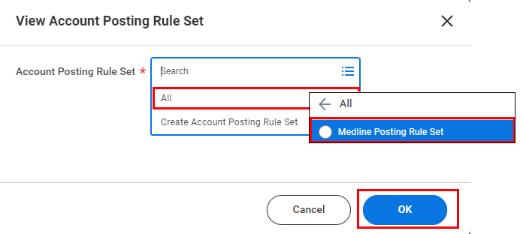

- Within an account set, you can define ledger account for each account posting type used by Payroll, which typically includes Cash, Payroll Earnings, Payroll Deductions, Payroll Expense, Payroll Net Pay, and Retained Earnings.

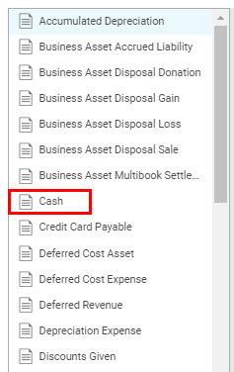

- Under the specified account set, click Edit Posting Rule to modify the conditions as needed.

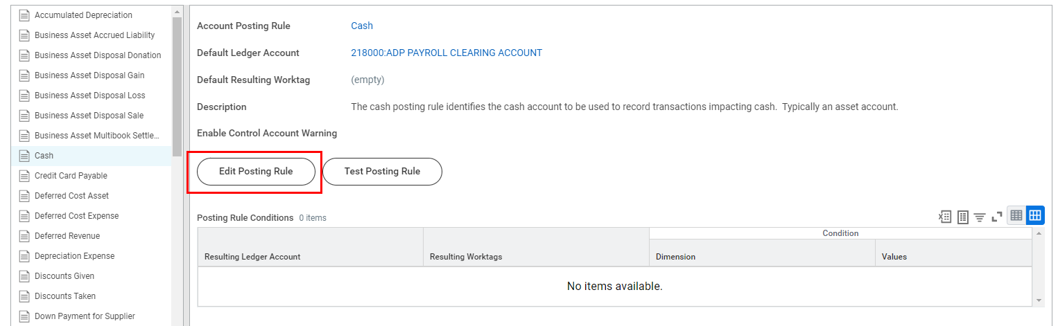

- To add a Posting Rule Condition, click the plus icon. Use the arrows in the second column to determine the Evaluation Order (items at the top will be executed first) and the third column to select a Ledger Account. Once done, click OK.

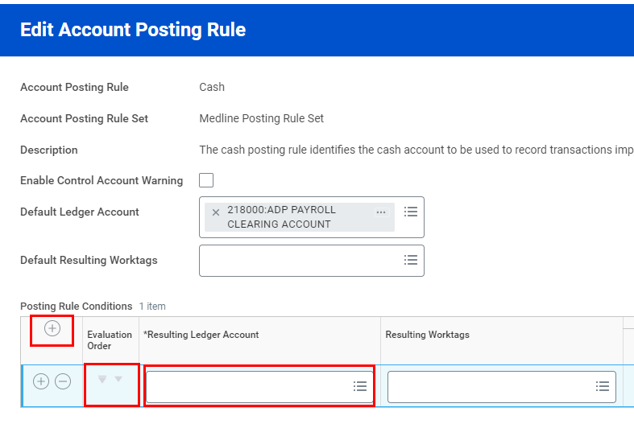

- To view an account set, type “View Account Set” in the Workday Search Bar, then select the corresponding report.

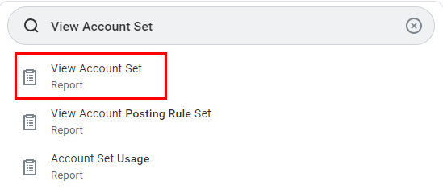

- Select an Account Set from the drop-down menu. First, click All, then the appropriate option. Once done, click OK.

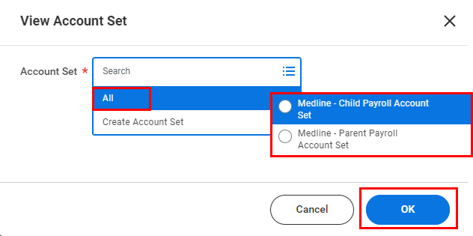

- Scroll to view the list of Ledger Accounts in the select account set.

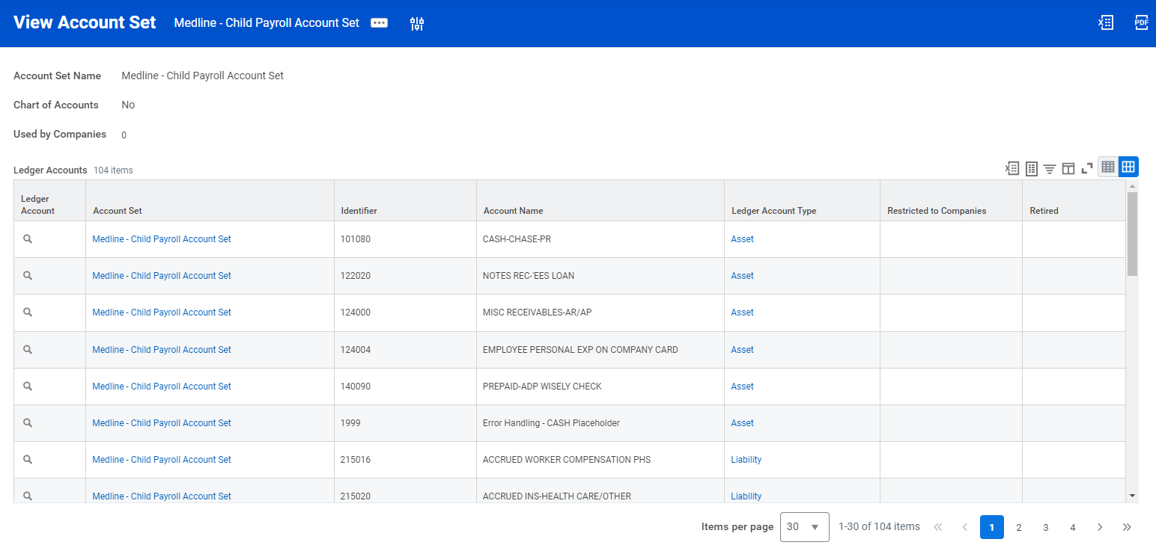

- For more information, please visit the following guides in Workday Community linked below:
- Set Up Payroll Accounting
- Set Up Account Posting Rules

