

Viewing Compensation Data
Managers

Workday has multiple ways for viewing compensation data. This document will outline the top two approaches: using your Org Chart and the Search Bar.
Option 1: Org Chart
- To get started, click on the Menu icon in the top left-hand corner of your screen. Select the My Team Management application.

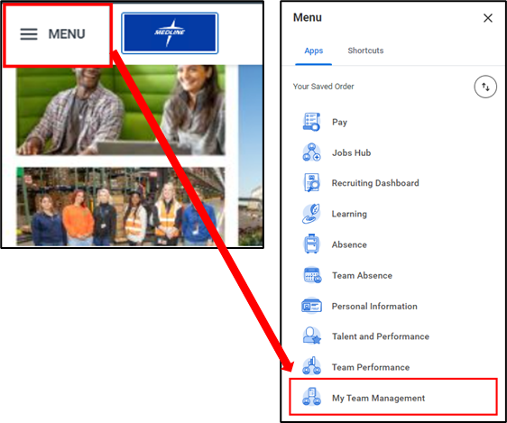

- From the dashboard under the View column, you can select My Org Chart to view all your direct reports.

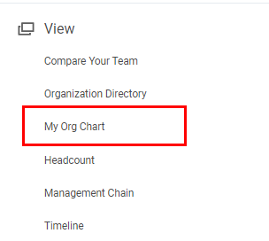

- Click the employee whose Workday Profile you wish to view.

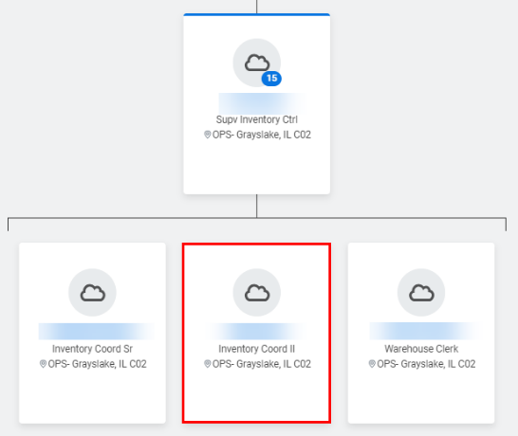

- You will be brought to the employee’s Workday Profile Summary. Click the Compensation tab on the left-hand side of the screen.

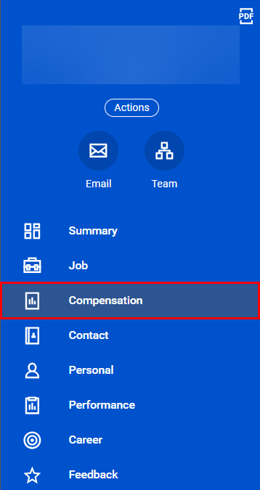

- From here, you can toggle between sub-tabs that would include Cash Overview and Compensation.

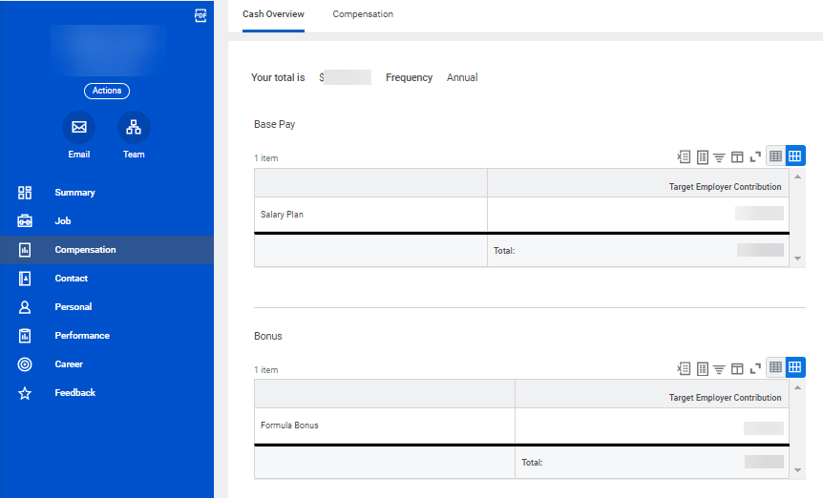

Please note that additional sub-tabs may be displayed on the employee’s compensation page depending on their role.

- On the Compensation tab, click on the Expand icon () to expand the chart to full screen for easier viewing. You can export this data to Excel by clicking on the Excel icon ().

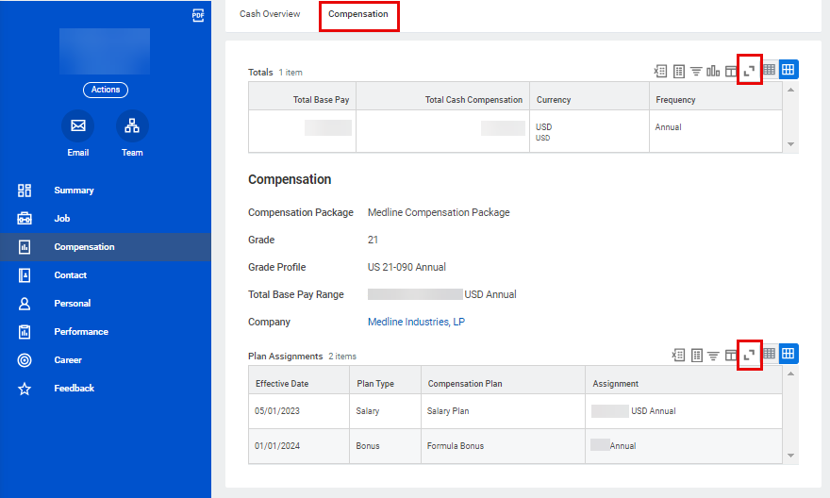
- You can also find compensation reports by typing the name of the report or key words in the Search Bar. Some helpful reports include Direct Reports Compensation, Compensation Spreadsheet and Compensation Summary. Reports available to you will depend on your role.

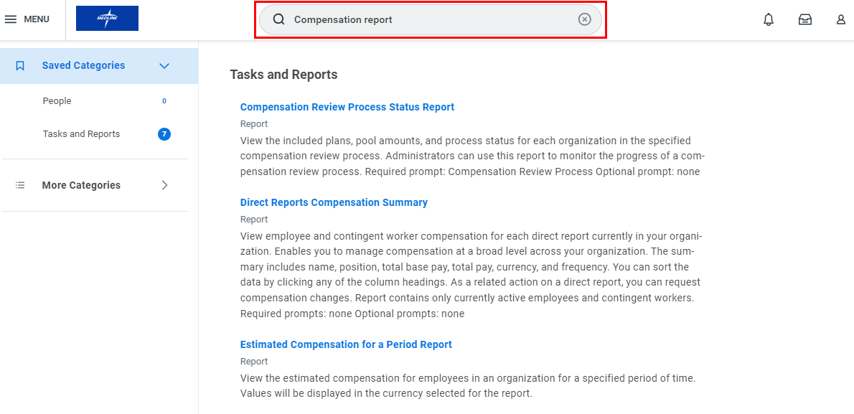

- Select the report you wish to view from the search results. You may need to include the following information. Then, click OK to proceed.
- Date: The date up to which you would like to review the data.
- Organization: Type your name to see data for your specific organization.
- Include Subordinate Organizations: Click this checkbox to see your entire direct and indirect data.

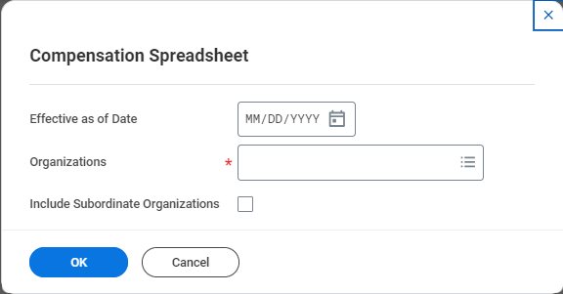

- Here, you will see the report. You can export this data to Excel by clicking on the Excel icon () or save the report as a PDF by clicking the PDF icon ().
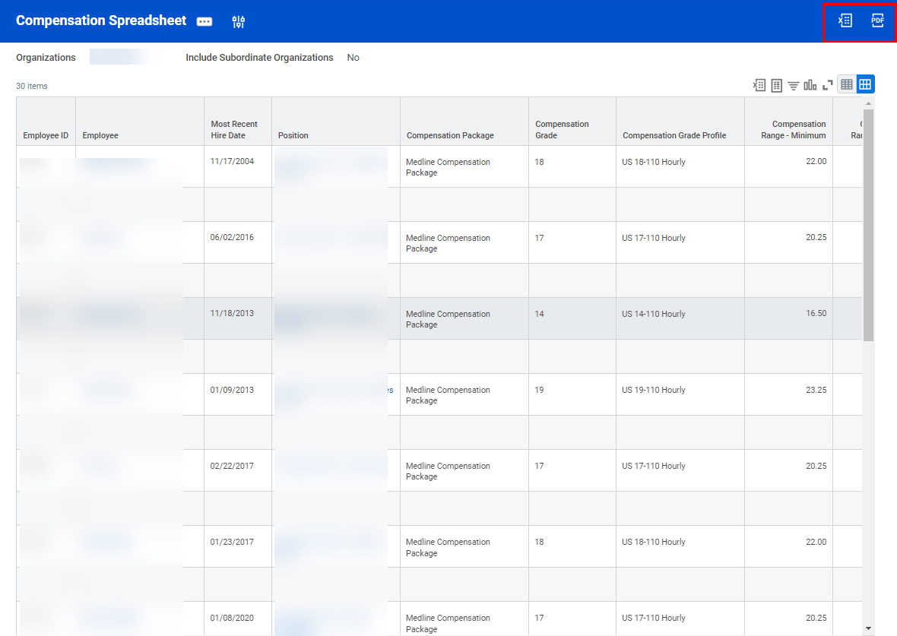

Option 2: Using the Search Bar
- Alternatively, you can type the name of the employee in the Search Bar. Then, select the employee from the drop-down list of options.

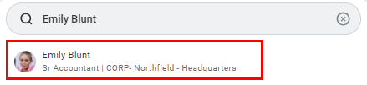

- Proceed with Step 4 of the previous section, Option 1: Org Chart.

