**Compensation Changes**

Managers

For Managers looking to individually request a special incentive (one-time payment) for their employee, this document will guide you through the following tasks and processes:

**Requesting a Compensation Change**

How to implement a compensation adjustment for an employee including changes to base salary, commission structure, and formula bonus.

**Requesting a One-Time Payment**

How to request a one-time payment for an employee.

Requesting a Compensation Change

Managers are advised to use the Compensation Change business process to implement any type of compensation adjustment for an employee. This includes changes to base salary, commission structure, and formula bonus.

Workday has multiple ways for entering a compensation change. This document will outline the top two approaches: using My Team Management or accessing the employee’s Workday Profile.

**Option 1: Using My Team Management**

1. To get started, click on the **Menu** icon in the top left-hand corner of your screen. Select the **My Team Management** application.

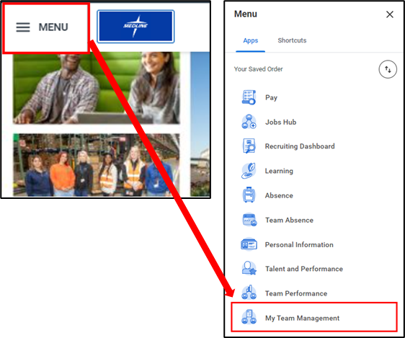

1. Under the **Actions** column, select **Request Compensation Change**.

|  |  |
| --- | --- |
|  | Please note that prior to entering a compensation change, you should be connecting with your HR Partner. |

1. Select the **Effective Date** and the **Employee** you are making the change for. If you wish to **Use Next Pay Period** as the effective date, select the checkbox. Click **OK** to proceed.

|  |  |
| --- | --- |
|  | Please note that if you are in the US, the Effective Date must equal a Pay Period Start Date. If you are in Mexico, the Effective Date must be a Monday. Please click this [link](https://urldefense.com/v3/__https:/medlinehr.zendesk.com/hc/en-us/categories/10040954308365-Manager__;!!O7V3aRRsHkZJLA!DX2KiegRnkTZiRvN4f16GIY32hWw30PRDsl1FzPDzMEef7_rYvVneYErZsH37Q7yMAYBE1fThAn_-iuB8rsu$) for payroll calendars. |

1. Click the **Edit** icon () to make changes to the necessary fields.
   1. The **Effective** **Date** will automatically populate based on your responses on the previous page.
   2. Select the **Reason** for the compensation change from the drop-down menu.

1. You can set an **Employee Visibility Date**. This is when the employee can see the compensation change. If you leave it blank, it will default to the **Effective Date**.

1. Carefully review the pay **Guidelines** for the role.

1. When making changes to the **Base Salary** or **Hourly** pay, click the **Edit** () icon, then input the new salary/hourly amount in the **Amount** field. This will automatically update the **Amount Change** and **Percent Change** fields. Alternatively, you can enter the **Amount Change** or **Percent Change**, and the **Amount** will adjust accordingly.

The **Currency** and **Frequency** will be automatically populated based on the role. If you require any modifications to these fields, please consult your HR Business Partner. Then, click the **Checkmark** icon () to save your changes.

1. If you need to make changes to the Formula Bonus Cap % for an employee who is eligible for this program, click the **Edit** icon(), then enter the **Individual Target %**. Click the **Checkmark** icon () to save your changes.

|  |  |
| --- | --- |
|  | **Please do not make any changes to the Commission or Allowance fields.** Sales compensation plan changes should only be done by the sales compensation team. |

1. Business justification (comments) are required for all compensation changes. A red alert, hard stop error, will generate if you do not enter a comment. Please provide the business justification for the compensation change in the **Comment** section.

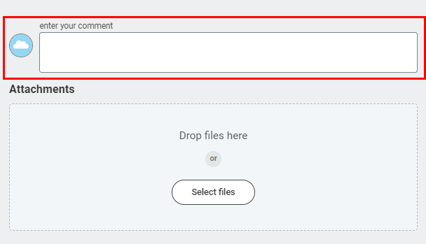

1. Once all fields are completed, click **Submit**.

1. Upon submission, you will receive a confirmation notice. The request will then be routed to the next level approver in the approval chain. In this case, it will route to the HR Partner, followed by the Manager and VP approvers.

1. During the approval process, you can navigate to the **Compensation Change** item in your **Archive Inbox** to track the progress of the compensation change request.

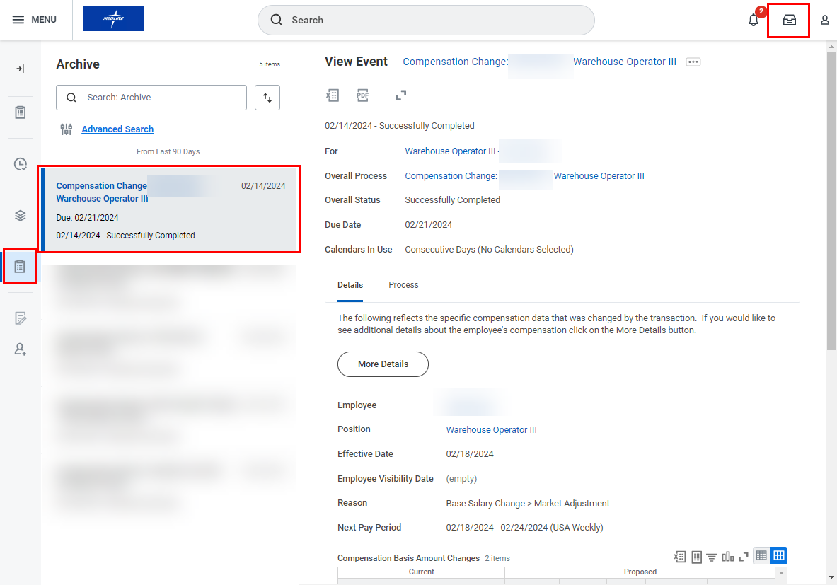

**Option 2: Accessing the Employee’s Workday Profile**

1. Alternatively, search for the employee whose compensation you are changing by typing their name in the **Search** **Bar**. Navigate to their **Workday Profile** by clicking their name from the search results.

1. Using related **Actions**, click **Compensation**, then **Request Compensation Change**.

1. Proceed with **Step 3** from the previous section, *Option 1: Using My Team Management.*

Requesting a One-Time Payment

Workday has multiple ways for requesting a one-time payment. This document will outline the top two approaches: using My Team Management or accessing the employee’s **Workday Profile**.

**Option 1: Using My Team Management**

1. Click the **Menu** icon in the top left-hand corner of your screen. Select the **My Team Management** application.

1. Under the **Actions** column, select **Request One-Time Payment**.

1. Select the **Effective Date** and the **Employee** you are making the change for. Click **OK** to proceed.

1. Click the **Edit** icon () in the **One-Time Payment Summary** section and select a **Reason**. You can also set an **Employee Visibility Date**. This is when the employee can see the One-Time Payment. If you leave it blank, it will default to the Effective Date. Click the **Checkmark** icon () to save your response.

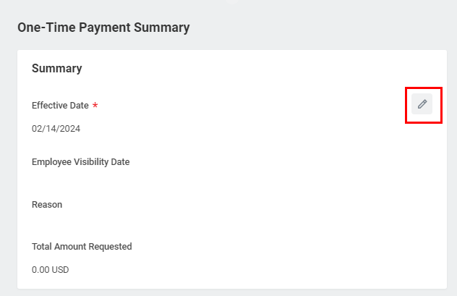

1. Under the **One-Time Payment** section, click **Add**.

1. Select the **One-Time Payment Plan** by clicking the drop-down and selecting the appropriate plan. Select the **Scheduled Payment Date** and enter the **Amount**. The appropriate **Currency** will populate automatically. **Note:** The amount entered must be within the guidelines of the **One-Time Payment Plan** selected.

1. You must then provide a business justification (comment) for the one-time payment request in the **Comment** section.



1. Click **Submit**, to submit the One-Time Payment for approval.

1. Upon submission, you will receive a confirmation notice. The request will then be routed to the next level approver in the approval chain. In this case, it will route to the HR Partner, followed by the Manager and VP approvers.

1. During the approval process, you can navigate to the **One-Time Payment** item in your **Archive Inbox** to track the progress of the request.

**Option 2: Accessing the Employee’s Profile**

1. Alternatively, search for the employee who you would like to request a one-time payment for using the **Search Bar**. Navigate to their **Workday Profile** by clicking their name from the search results.

1. Using related actions, click **Compensation**, then **Request One-Time Payment**.

1. Proceed with **Step 3** from the previous section, *Option 1: Using My Team Management.*