

Managing Pay Information
Employees

For employees looking to access or manage their pay information, this document will guide you through the following tasks:
Adding and Editing Direct Deposit in Workday
How to select preferred payment methods and update direct deposit information.
Viewing and Printing Payslips in Workday
How to view your previous payslips and print one or multiple payslips at a time.
Accessing Link to Update Tax Withholdings
How to update federal and state tax withholding information.
Contact Payroll (Instructions, Zendesk)
How to contact Payroll.
ADP Registration Instructions
How to register for ADP - a comprehensive payroll solution that will enable you to manage your wage payments, tax filings, and withholding orders.
ADP Earnings Statement & W2s
How to access the ADP Earnings Statements and W2s.

Adding and Editing Direct Deposit in Workday
- To get started, click the Pay application from your Workday Homepage.
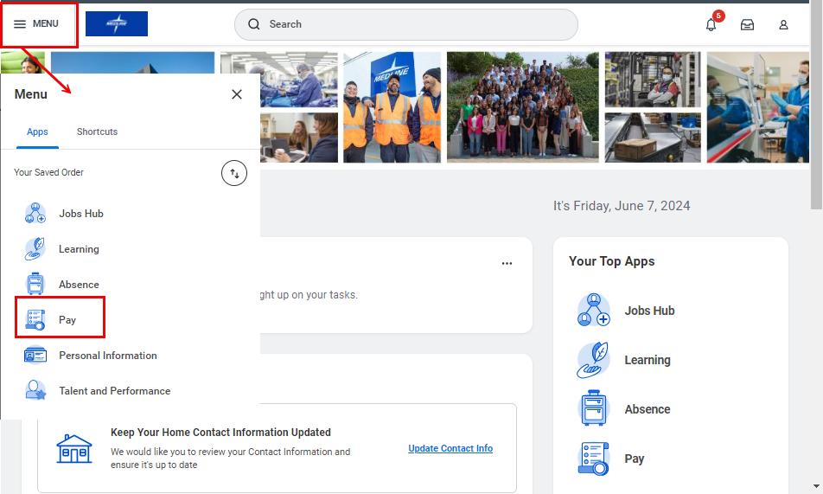

- Under the Elections menu, click Payment Elections.

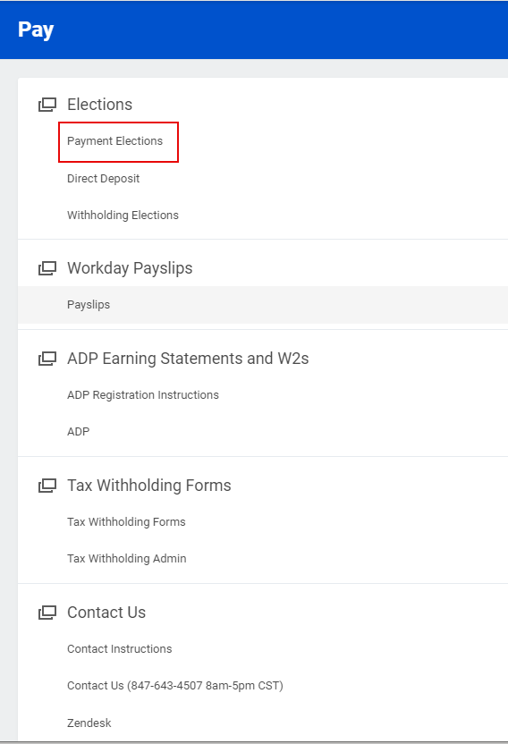

- Under Accounts, click Edit to update an existing payment election or Add to add an additional payment election.

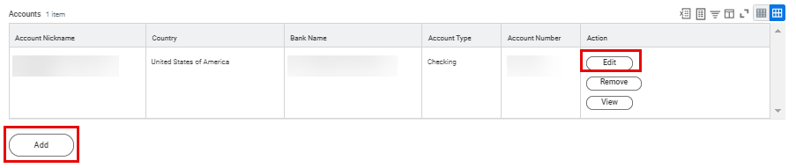

- Enter Account Information for your bank account, including Routing Transit Number, Account Number and Bank Name. Then, click OK.

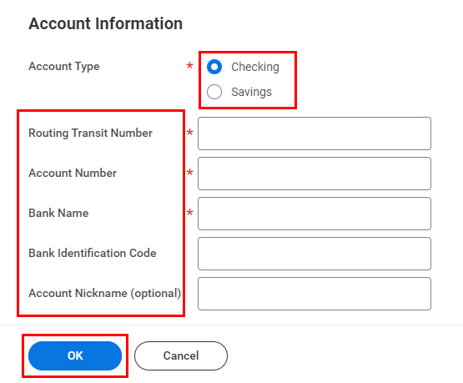

You can find this information on a blank check, as per the sample below.

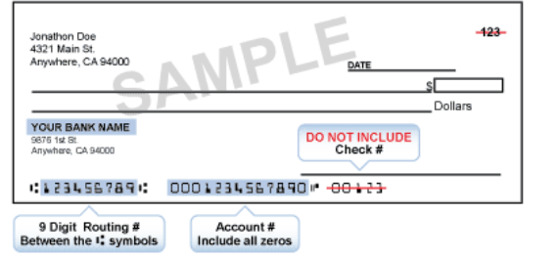

Please note that there is no pre-note. Check your information carefully to ensure accuracy.

- Next, scroll down to the Payment Elections table. Click Edit.
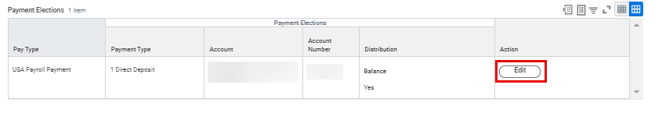

- Select your preferred Payment Type from the drop-down menu.

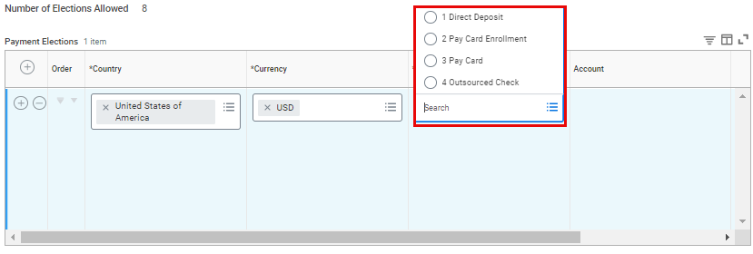
- If you would like to split payments between different accounts and only see one account listed, click on the Add icon () and select the account from the drop-down menu. Select United States of America in the Country column and the Currency will auto-fill to USD. Select your preferred Payment Type and select the account you would like to direct your payment to from the drop down menu. Then allocate payments as desired by Amount, Percent or Balance.

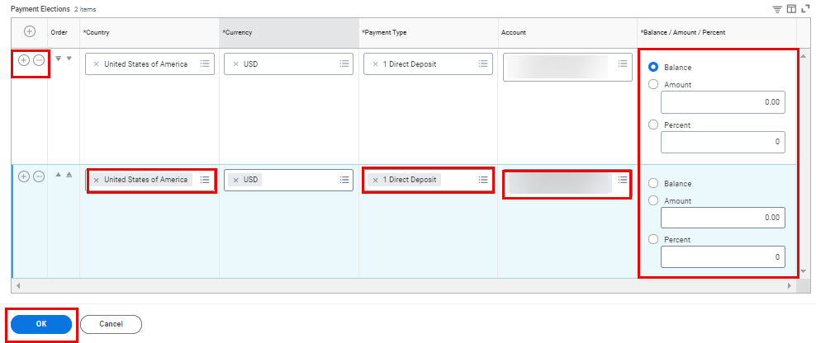

Please note that if you are splitting payments into multiple accounts, the last row (account) in the list must have the Balance selected, or the total percentage of all accounts must equal to 100.

- Once finished, click OK.

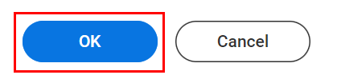

- A confirmation message will appear to notify you that your changes have been saved. You will also receive an automated email confirmation.



Viewing and Printing Payslips in Workday
- To get started, click the Pay application from your Workday Homepage.

- Under the Workday Payslips menu, click Payslips.

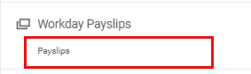

- The My Payslips page displays a summary of all your payslips to date. Next to each payslip record, you will see details about that particular payslip, such as the Payment Date, Gross Amount and Net Amount. You can also View or Print each payslip from here. Select View to be taken to the Payslip details.
Please note that payslips will not be available in Workday until the first payrolls are processed once Workday goes live.

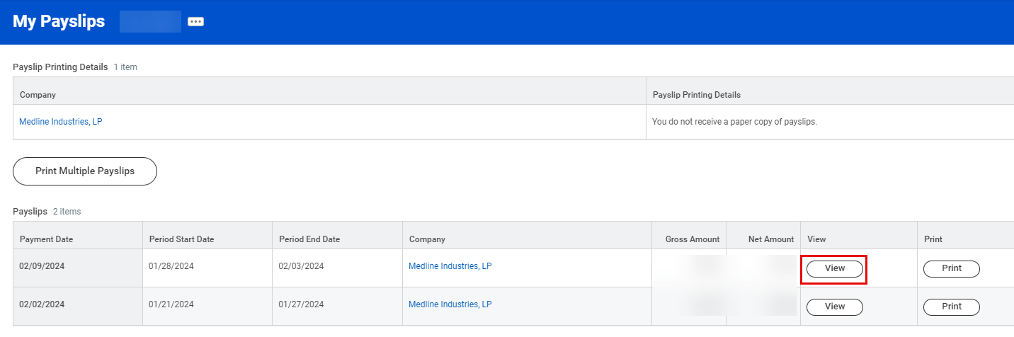

- Click View to see a detailed view of the selected payslip, including Current and YTD Totals, Earnings, Tax Information and more. You can export any of this information to Excel by clicking the Export to Excel () icon, and you can expand the view for easier reading by clicking the Expand () icon. From the top of the Payslip page, you can access:
- Previous Payslip – View your payslip for the previous pay period
- Return to My Payslips – Return to the previous page to see an overview of all your payslips
- Print Payslip Image – Print a copy of this payslip
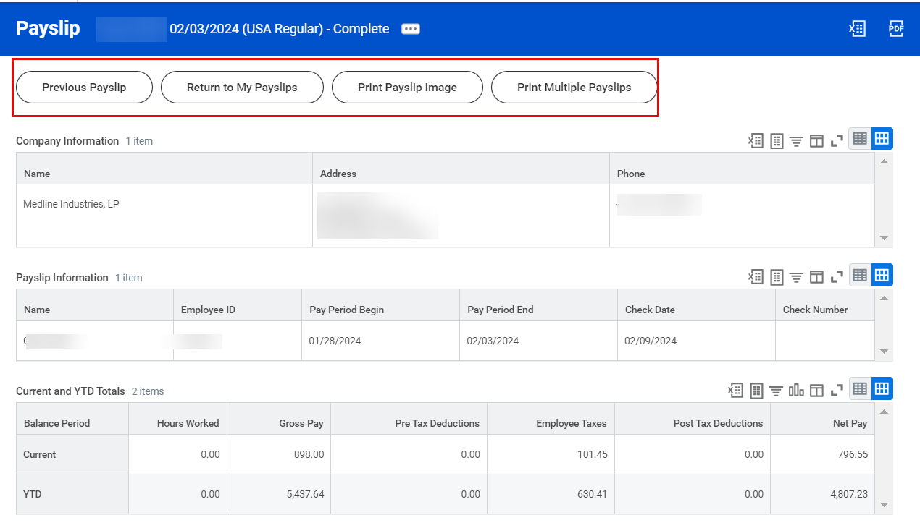
- Print Multiple Payslips – Print copies of multiple payslips all at once for your convenience

- There are multiple ways to print a payslip(s). From the My Payslips page, select Print to print a copy of an individual payslip, or Print Multiple Payslips to print multiple payslips at once. You can also complete this action from the Payslip details page (pictured above).
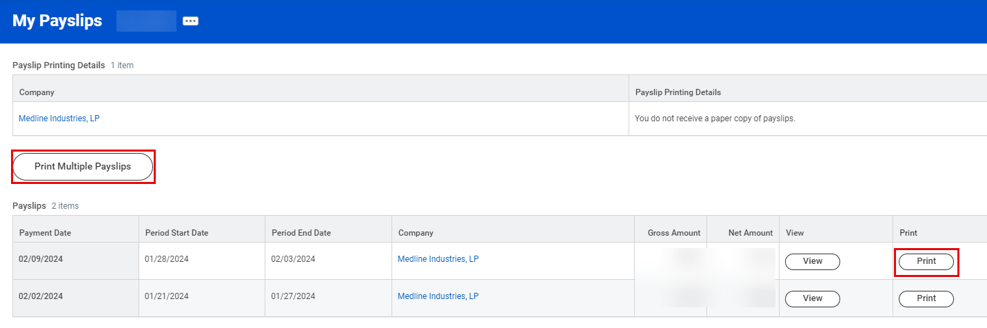

- If you select Print Multiple Payslips, you will be asked to input the following information. Then, click OK.
- Payment From Date and Payment To Date: Aggregate all payslips within the selected payment period.
- Exclude Net Zero Payslips: Exclude any payslips with net zero earnings from your search.
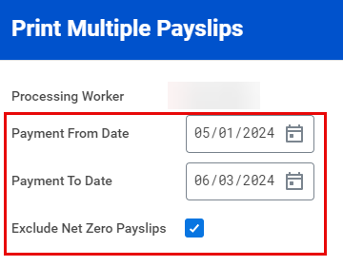

- On the next page, review all the payslips within the given Payment Date Range. Select the checkboxes in the table for the payslips you wish to print within the Payment Date Range, or select the top checkbox in the top row of the table to print them all. Then, click OK.
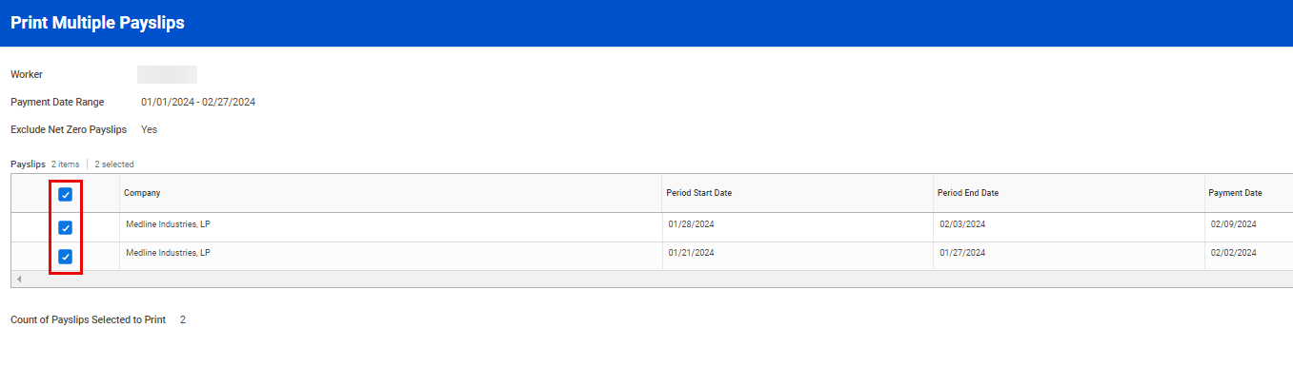

- Your payslip documentation will pop up automatically or a dialogue box notifying you that Workday is processing your request will appear. You can request that Workday notify you once the image is ready by clicking on Notify Me Later.
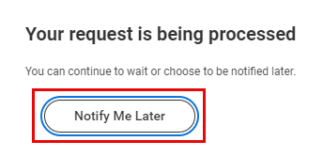

- If you have chosen the Notify Me Later option, Workday will send you a notification when your payslips are available for printing. You can access your notifications by clicking on the Bell icon () at the top right corner of the page. Once in your Notifications page, click on the Document Available item in the left pane. Following this, click the PDF beside Details on the right-hand side of the screen to open the payslip image.
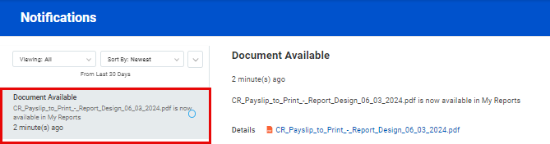

Please note that you can only view your current payslip two days before the actual payment date.

Accessing Link to Update Tax Withholdings
- To get started, click the Pay application from your Workday Homepage.

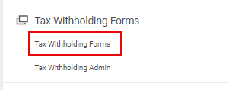
- Under the Tax Withholding Forms menu, click Tax Withholding Forms.

- You will then be redirected to the CIC Plus webpage, where you can proceed to update your tax withholding elections.

Contacting Payroll (Instructions, Zendesk)
- To get started, click the Pay application from your Workday Homepage.

- Under the Contact Us menu, click either Contact Instructions, Contact Us or Zendesk.
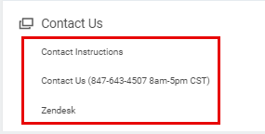

ADP Registration Instructions
- To get started, click the Pay application from your Workday Homepage.

- Under the ADP Earnings Statements and W2s column, click ADP Registration Instructions.
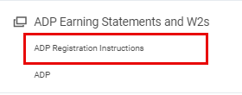

ADP Earnings Statement & W2s
- To get started, click the Pay application from your Workday Homepage.

- Under the ADP Earnings Statements and W2s column, click ADP.
