

Accessing Pay Information
Employees

Accessing ADP via Workday
ADP is a comprehensive payroll solution that will enable you to manage your wage payments, tax filings, and withholding orders. You can learn how to access this system with this guide.
- To begin, click the Pay application from the Applications Menu on your Workday Homepage.
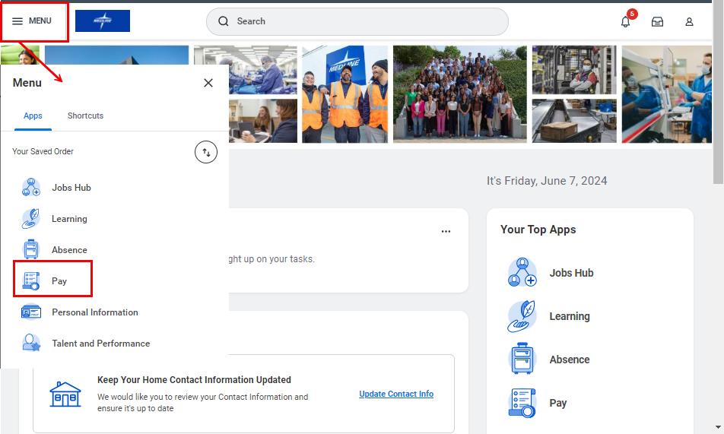

- On the Pay dashboard you can access your Elections, Payslips, Tax Withholding Forms and more. Under the ADP Earnings Statements and W2s menu, click ADP to be redirected to the ADP site.

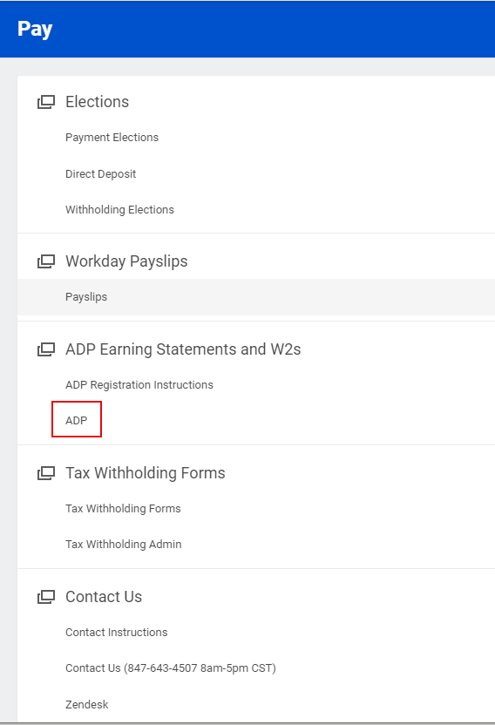

- You are now able to access the ADP site. Please enter your User ID and Password to complete the login process.

